# Bengali Letters

# 

# Vowels

| **Type** | **Phoneme (IPA)** | **Example Word** | **Description** |
| --- | --- | --- | --- |
| **Short Vowels** | অ , ই , উ | অমি, তুমি | Brief in duration |
| **Long Vowels** | আ, ঈ , ঊ | রাম, নীল | Longer in duration |
| **Diphthongs** | ঐ, ঔ | ঐক্য, মৌ | Glide between two vowels |

## Short Vowels

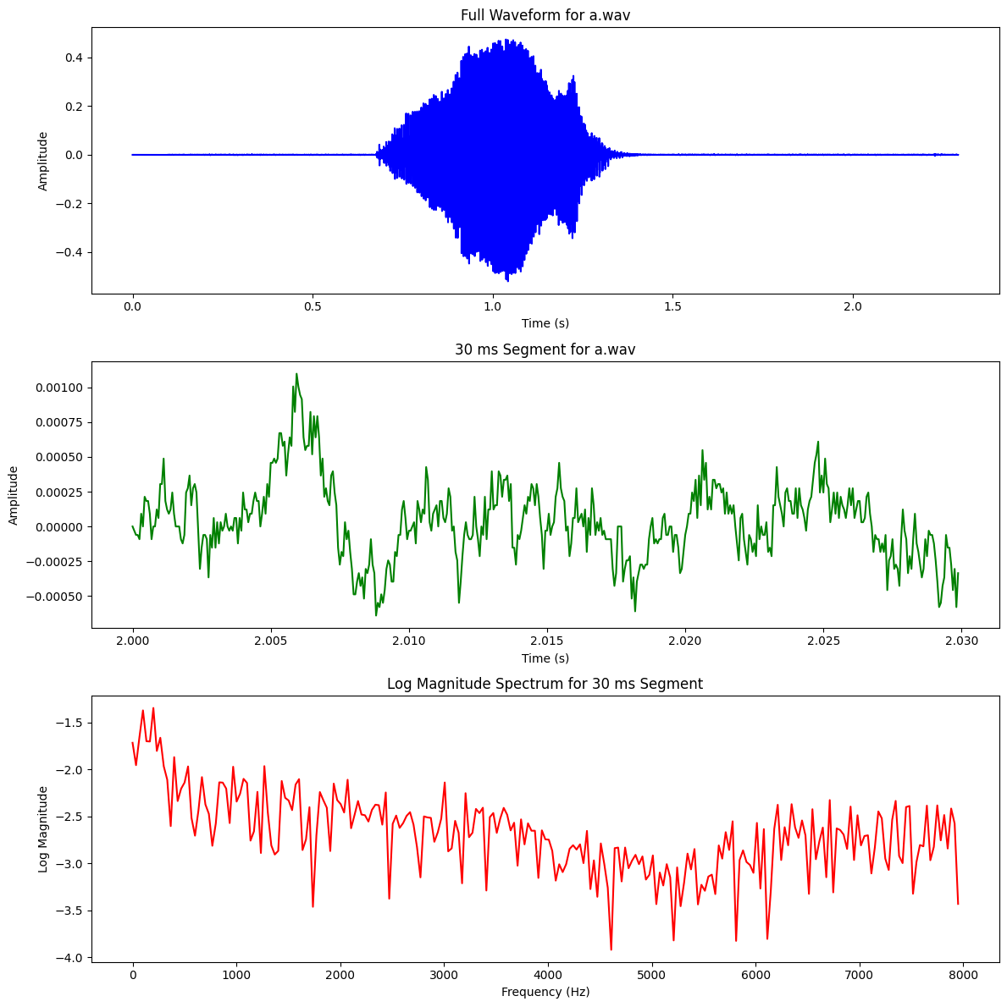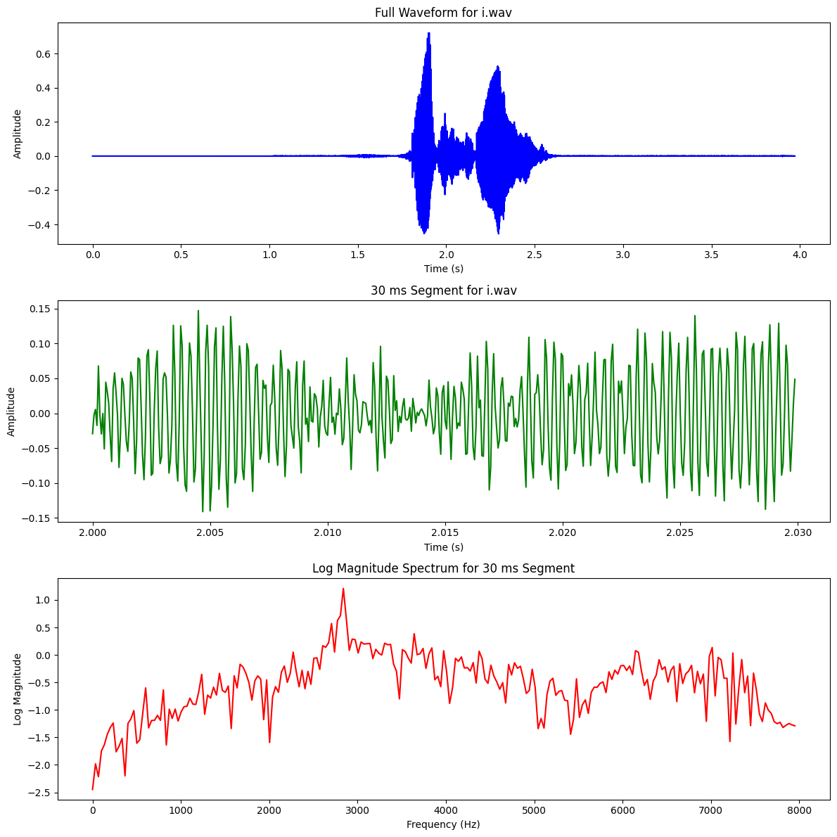

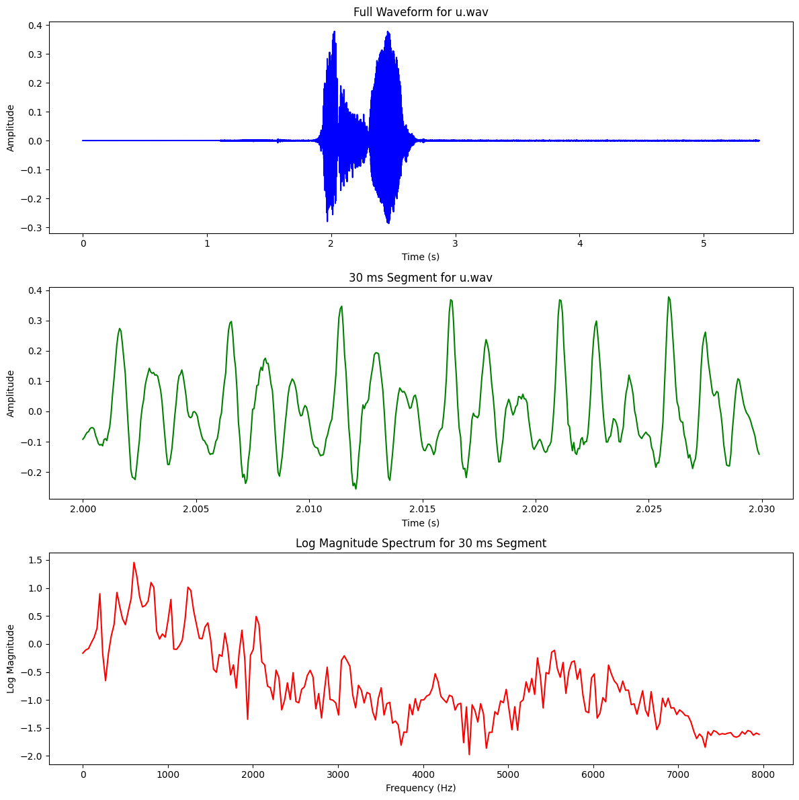

# Vowels – Long

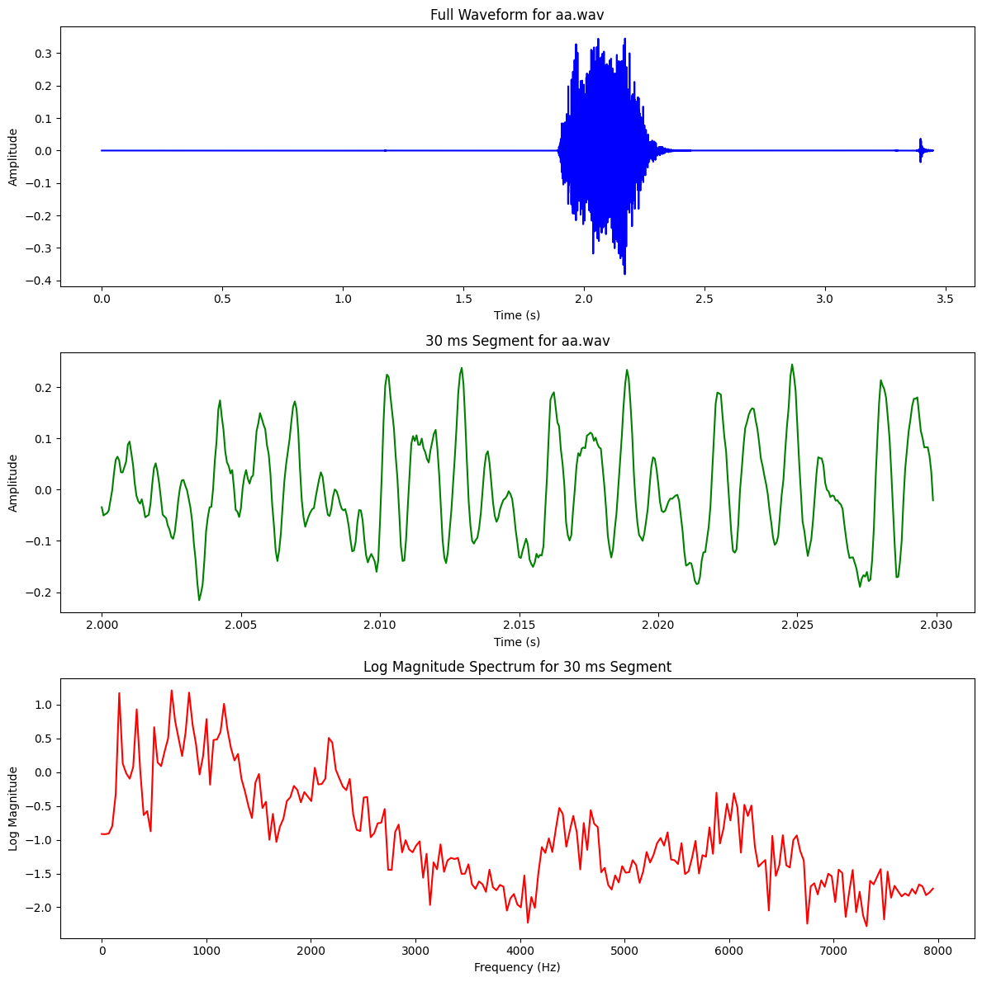 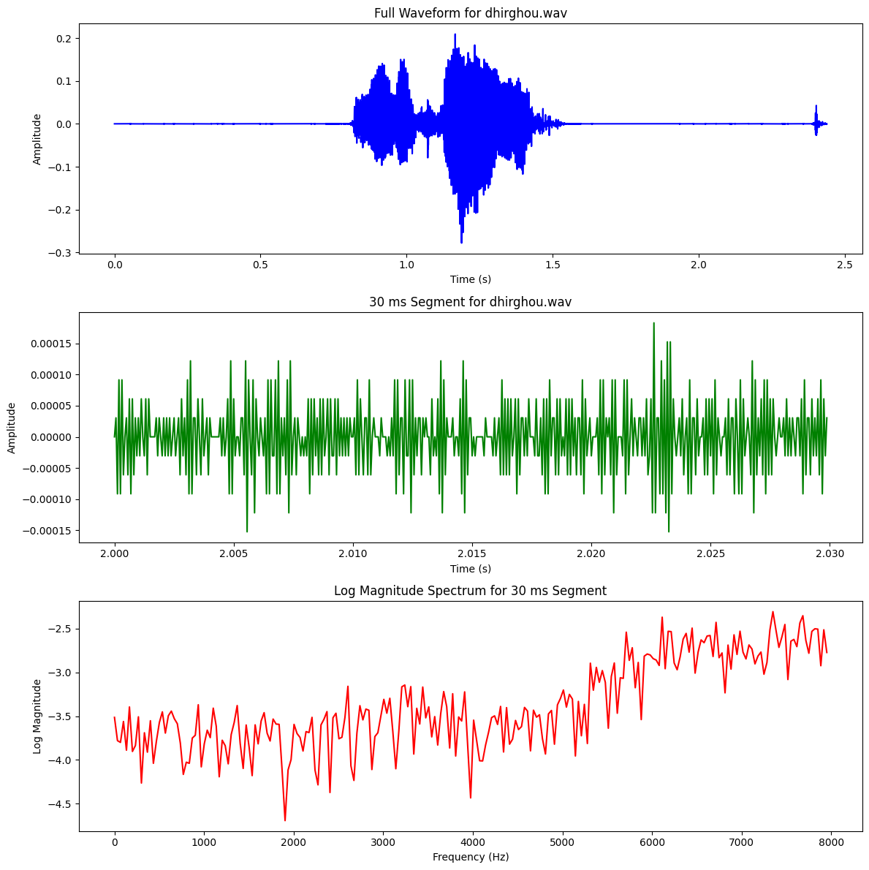

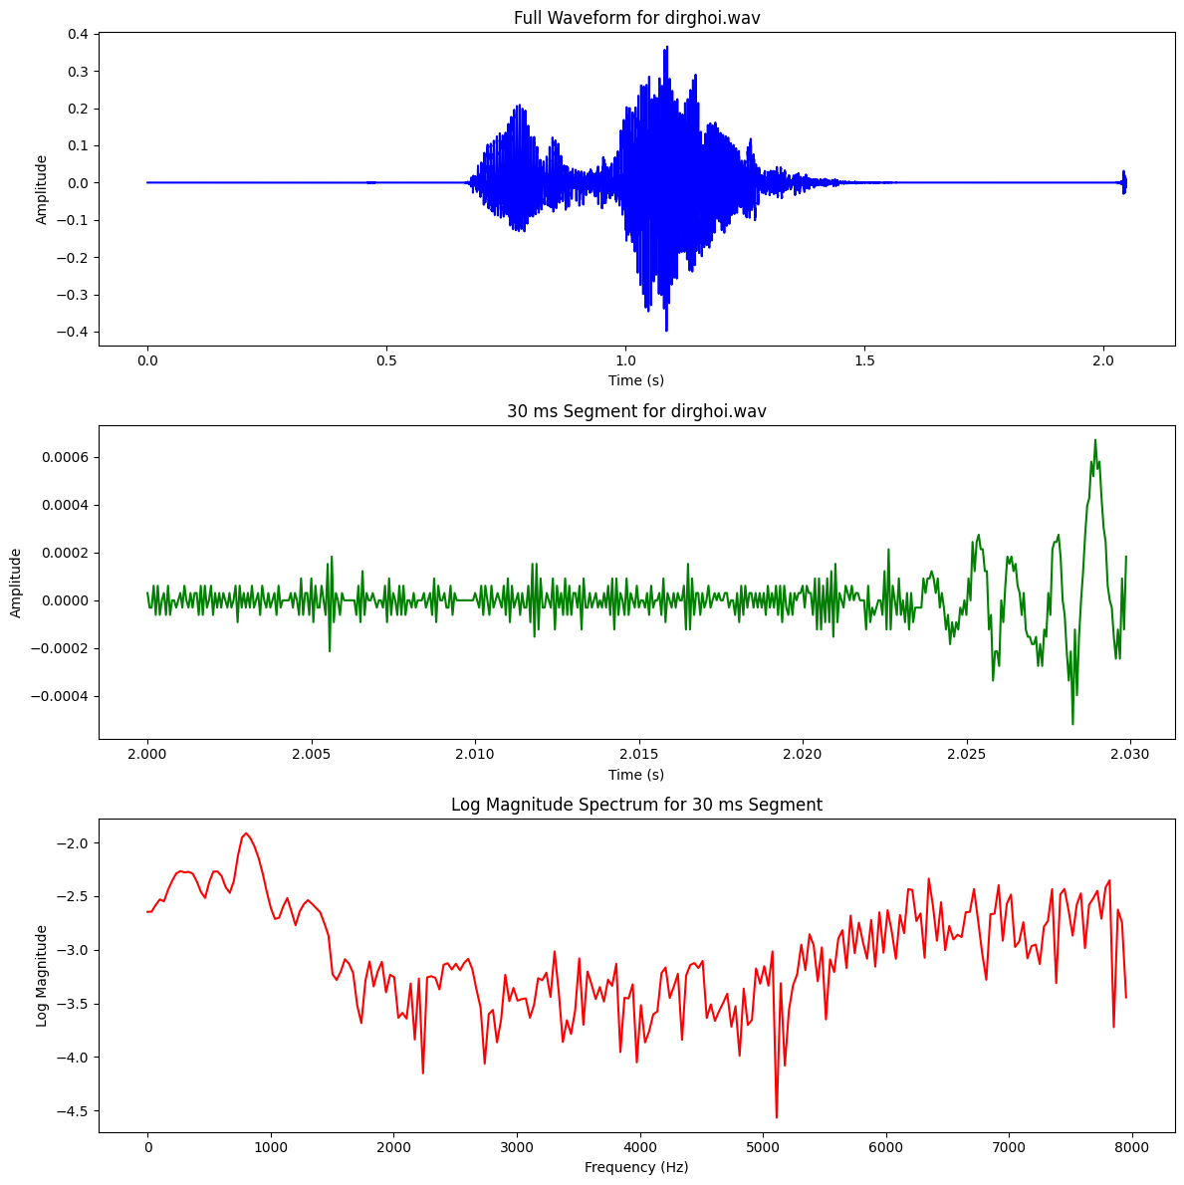

# Dipthongs

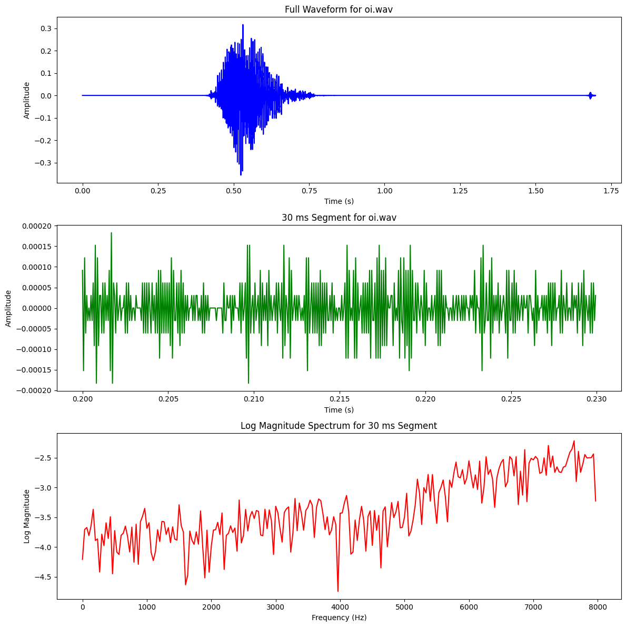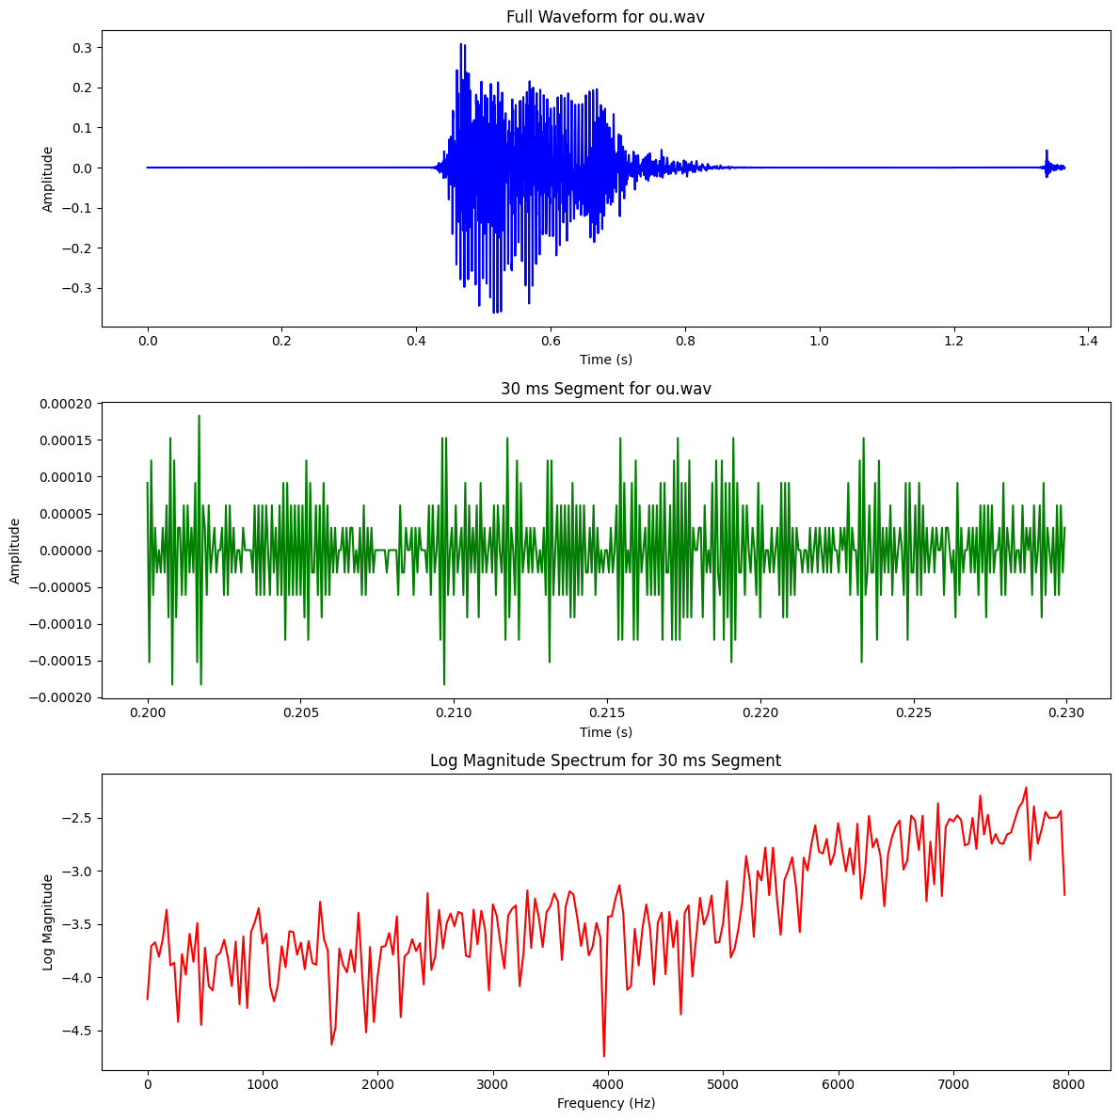

# Consonents – Stops

| **Type** | **Phoneme (IPA)** | **Place of Articulation** | **Manner of Articulation** |
| --- | --- | --- | --- |
| **Affricates** | চ , ছ | Palatal | Stop + Friction (Affricate) |
| **Fricatives** | শ , ষ, স | Alveopalatal, Retroflex | Fricative |
| **Nasals** | ম , ন, ঙ, ণ | Bilabial, Alveolar, Velar, Retroflex | Nasal |
| **Semivowels** | য , র, ল | Palatal, Retroflex, Alveolar | Approximant (Semivowel) |
| **Stops** | ক, খ, গ, ঘ,… | Velar, Palatal, etc. | Blocking Airflow |

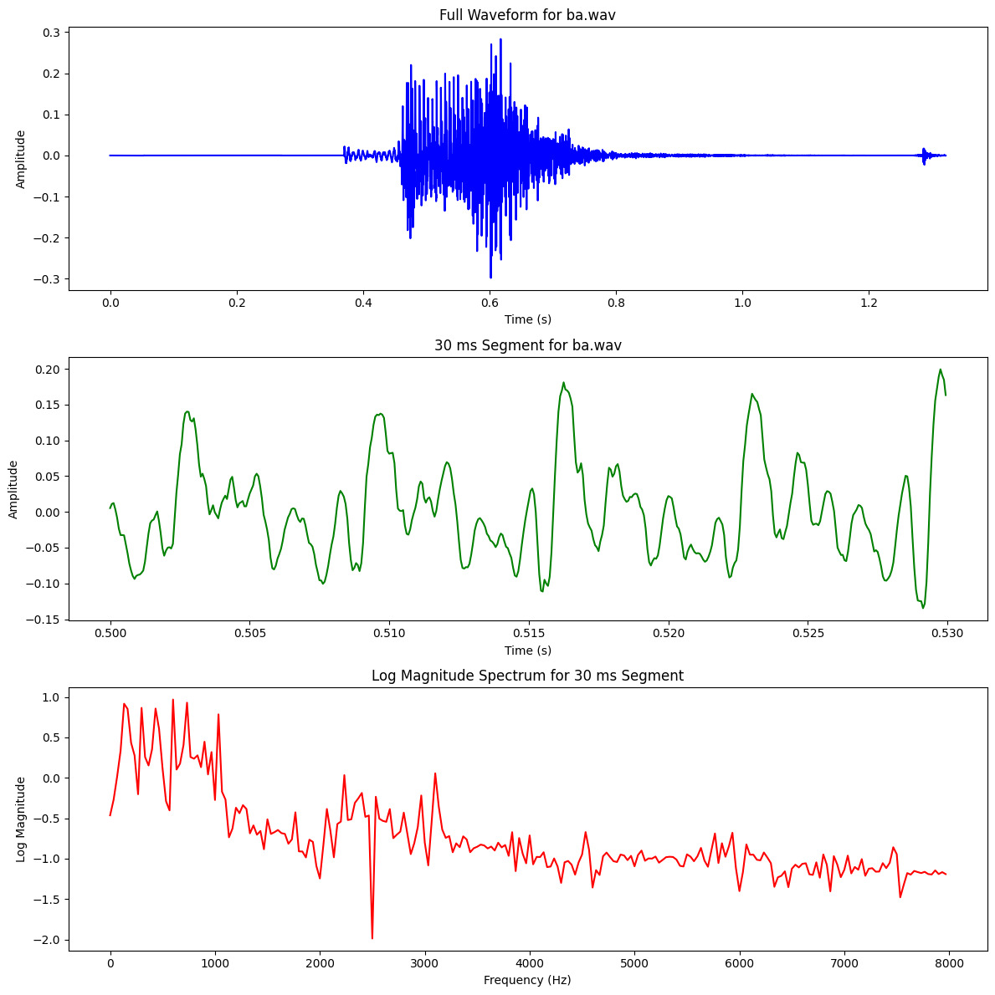 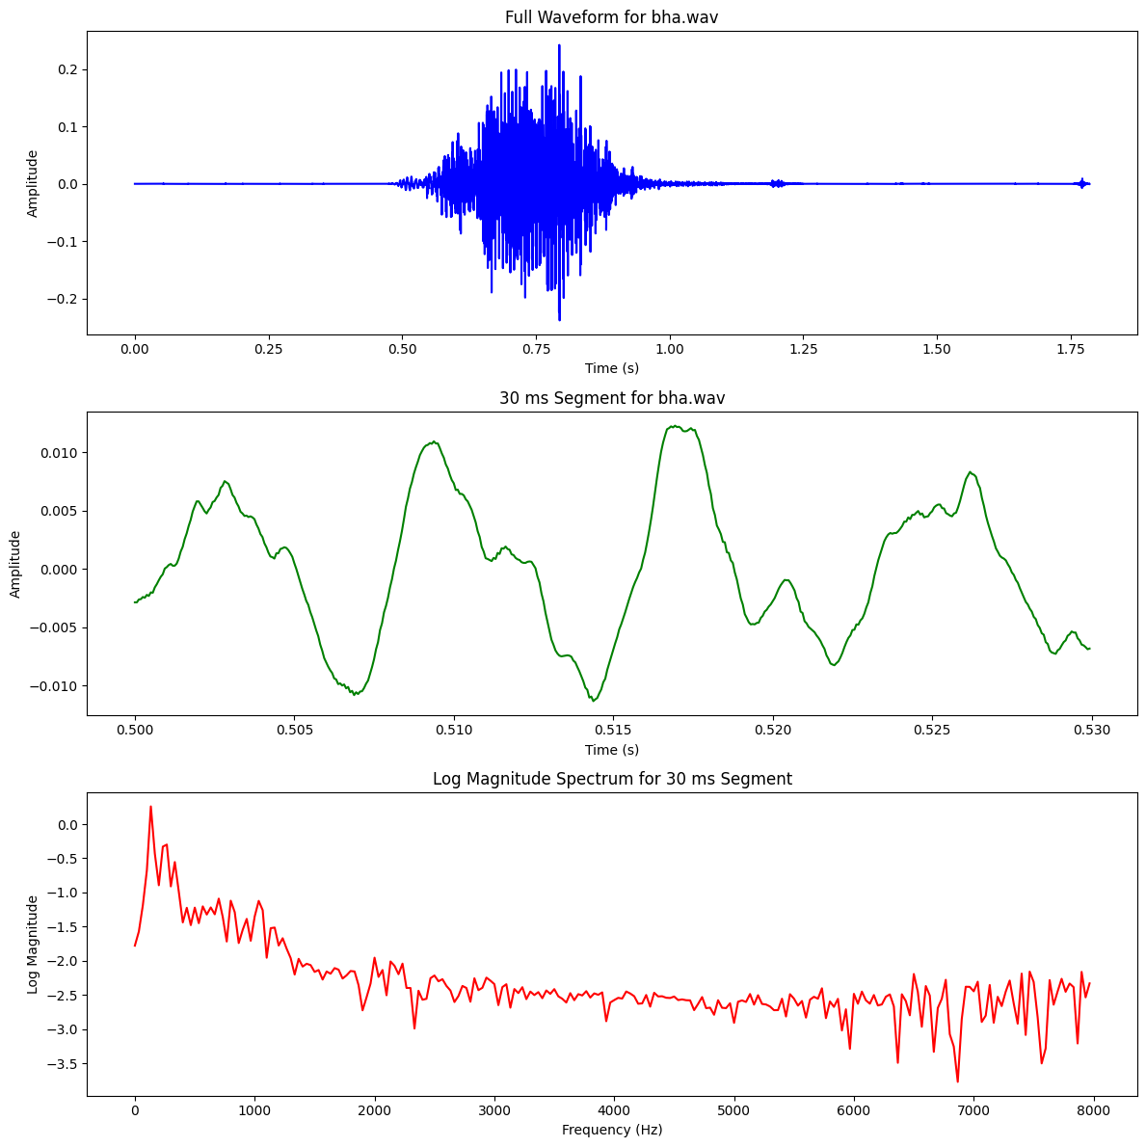

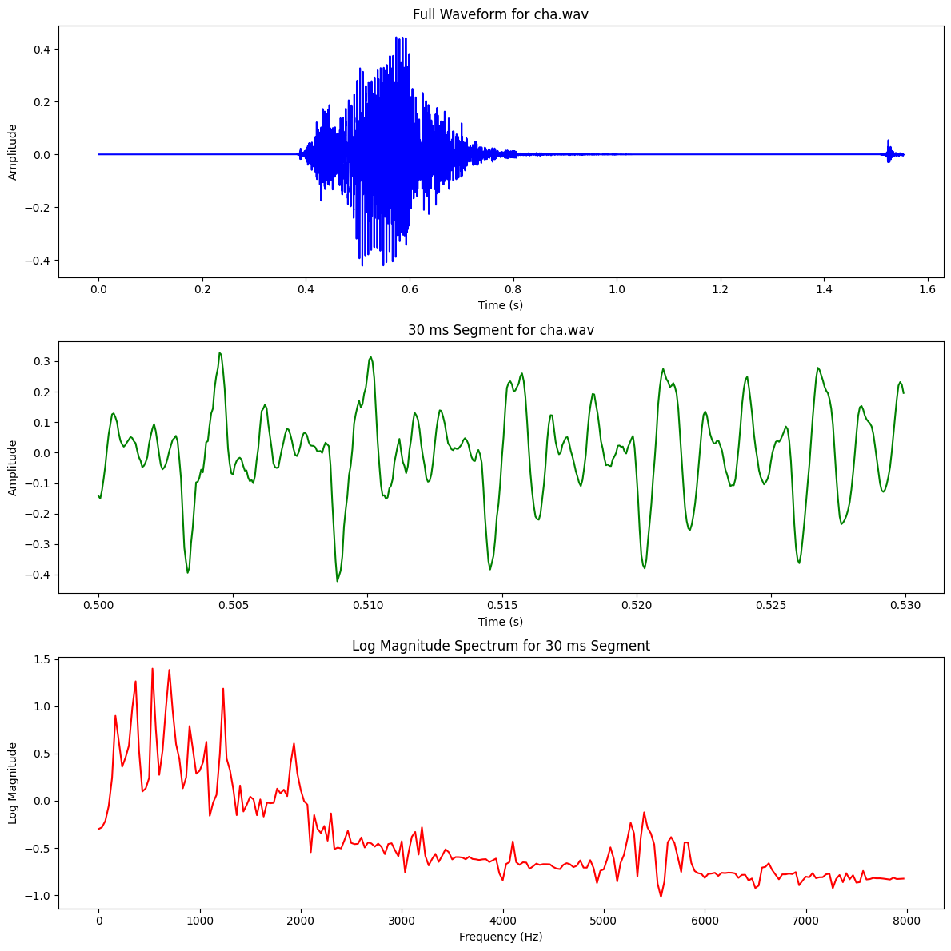 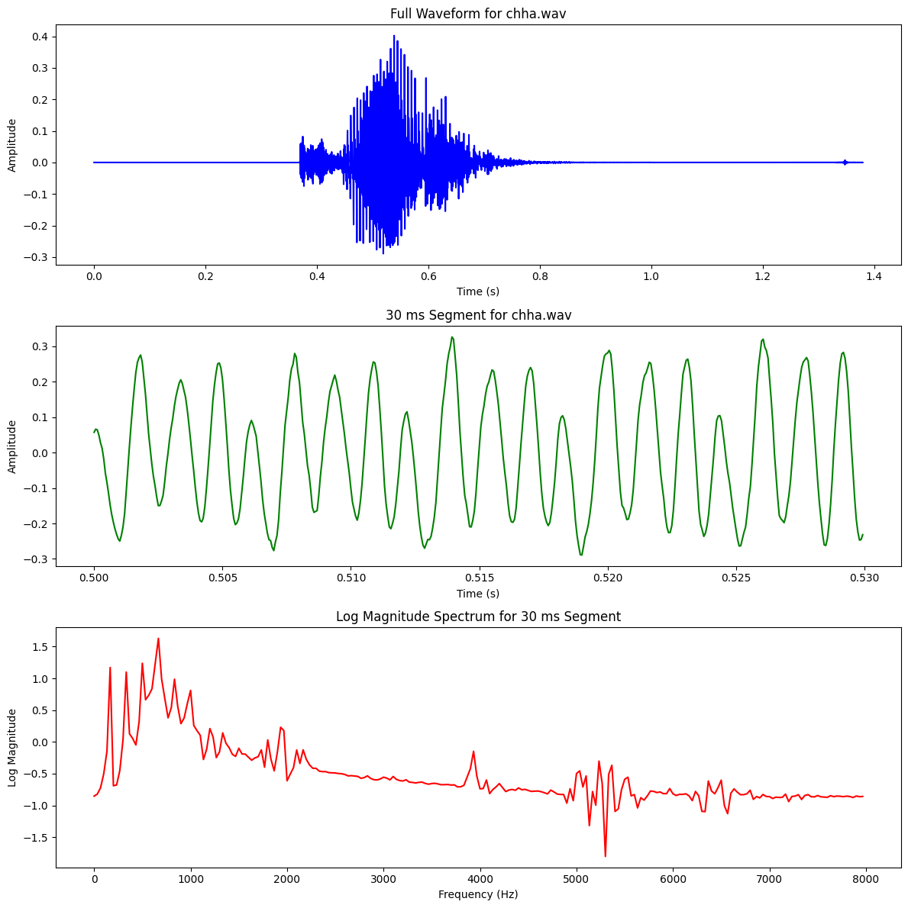

# 

# 

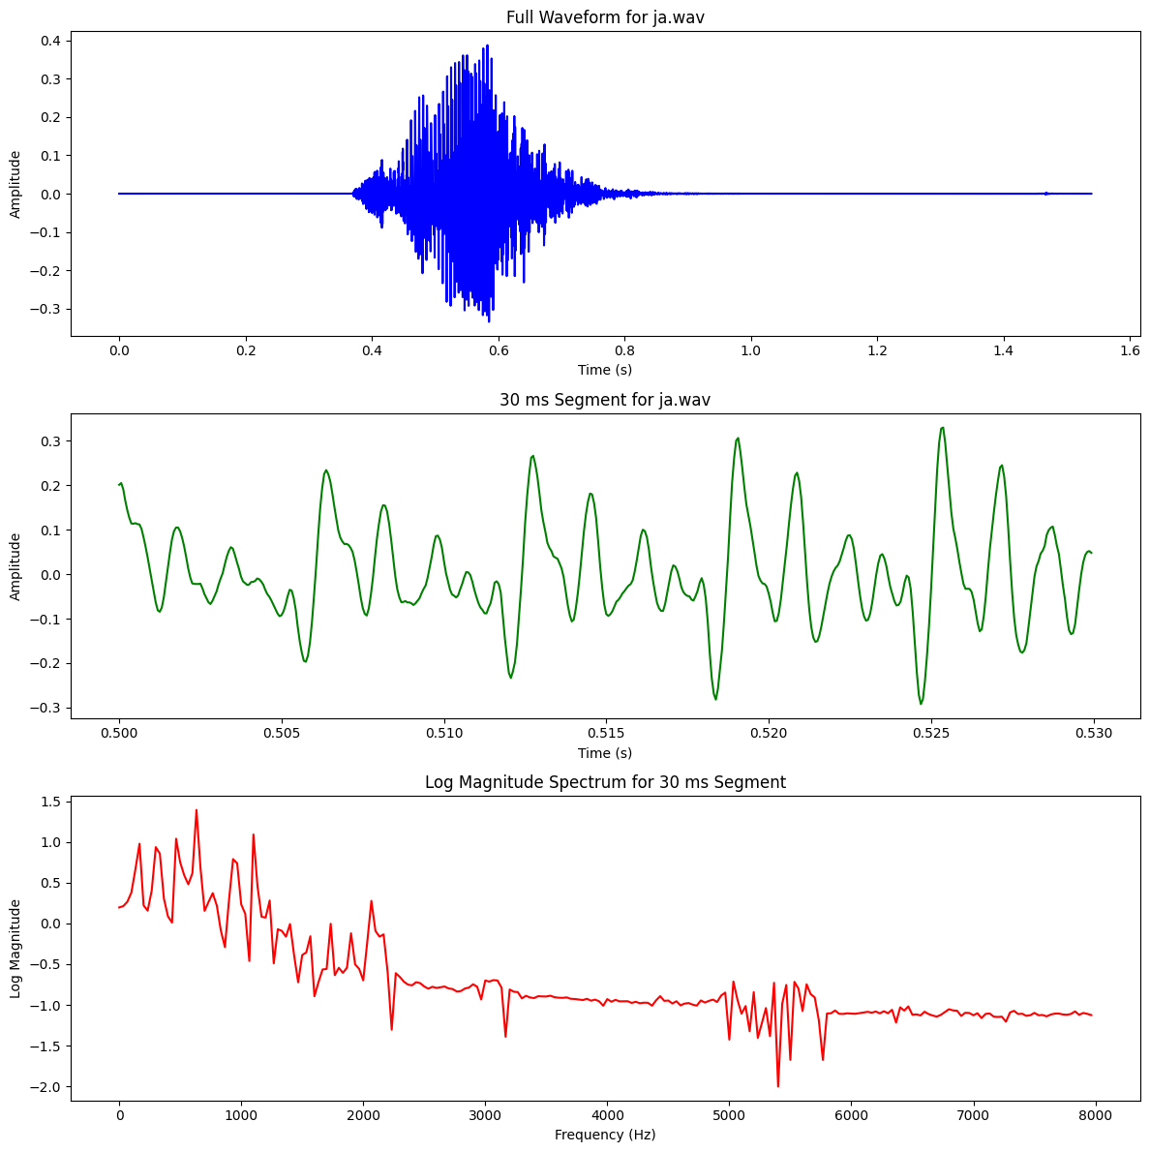 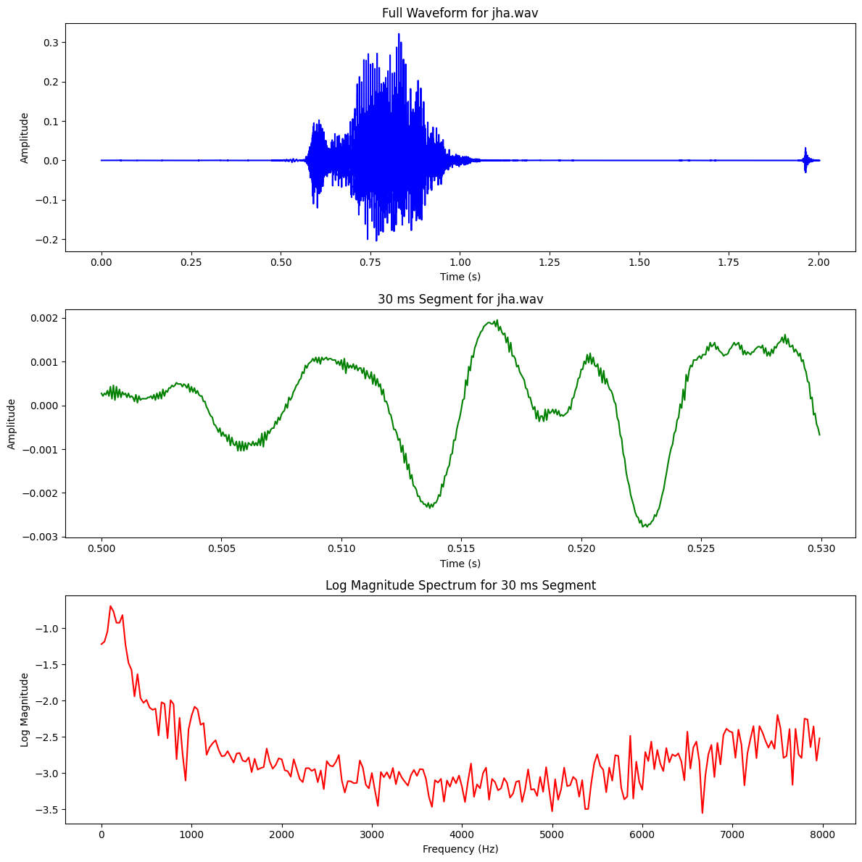

# 

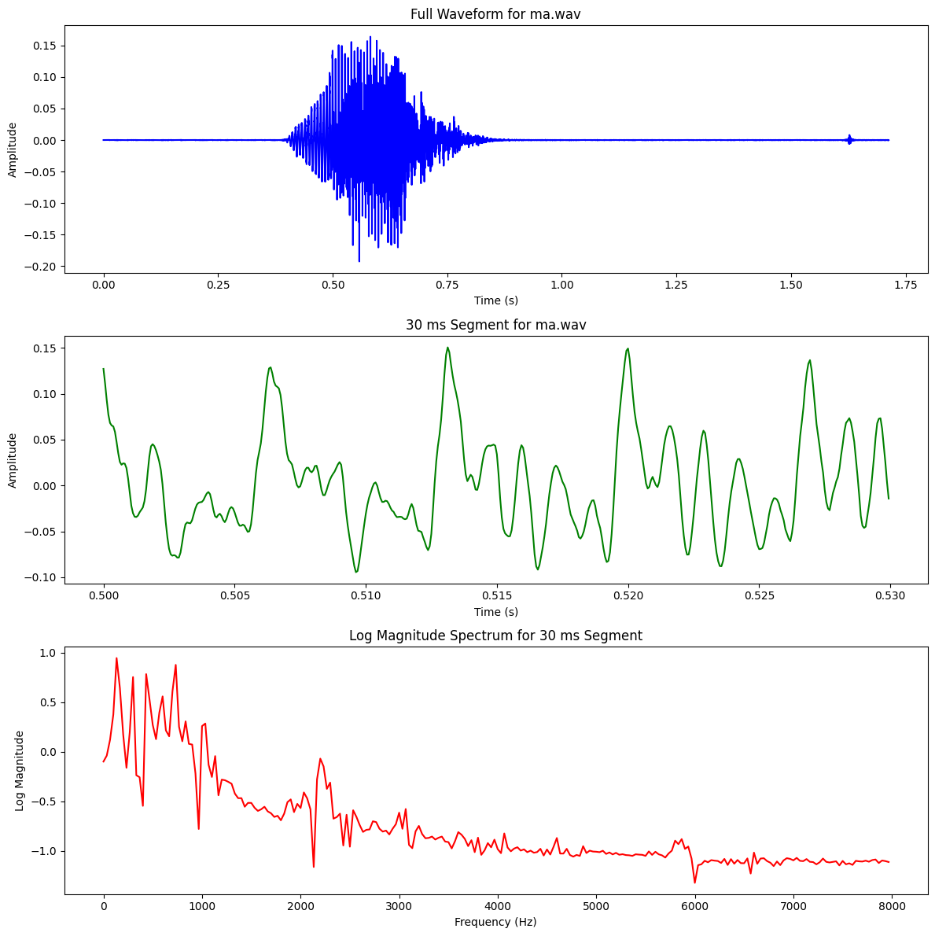 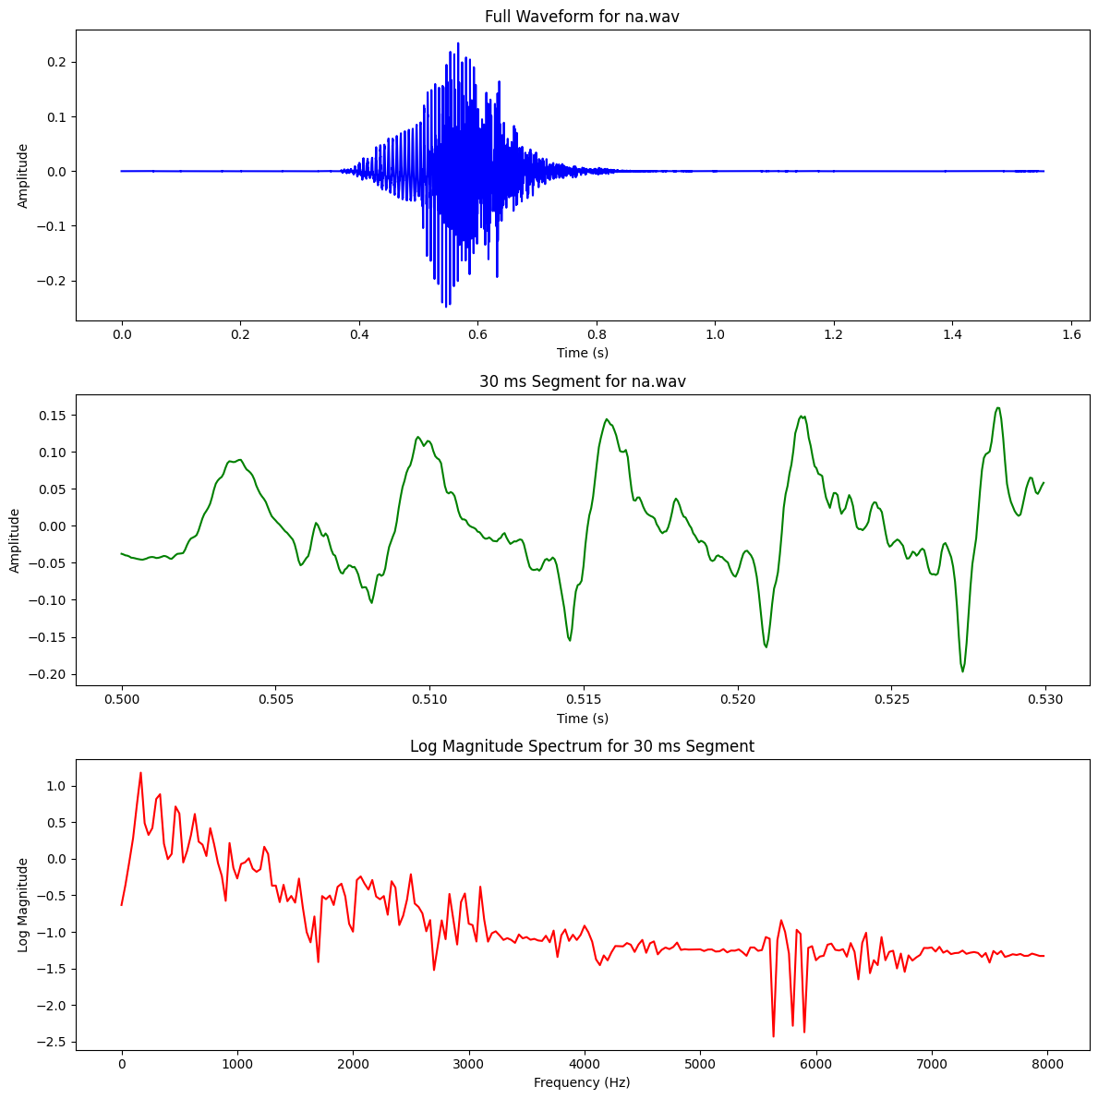

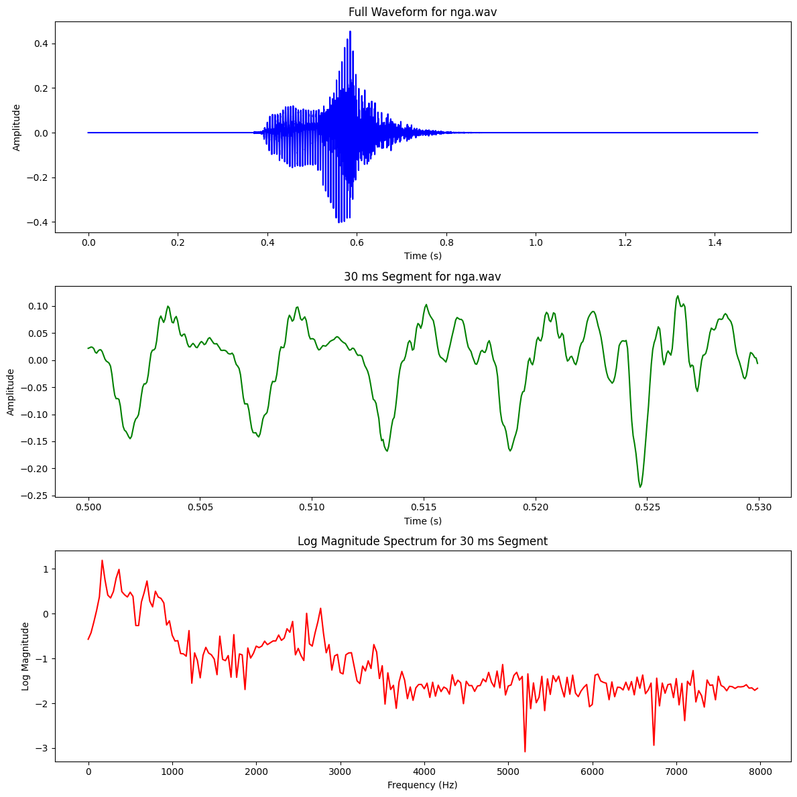 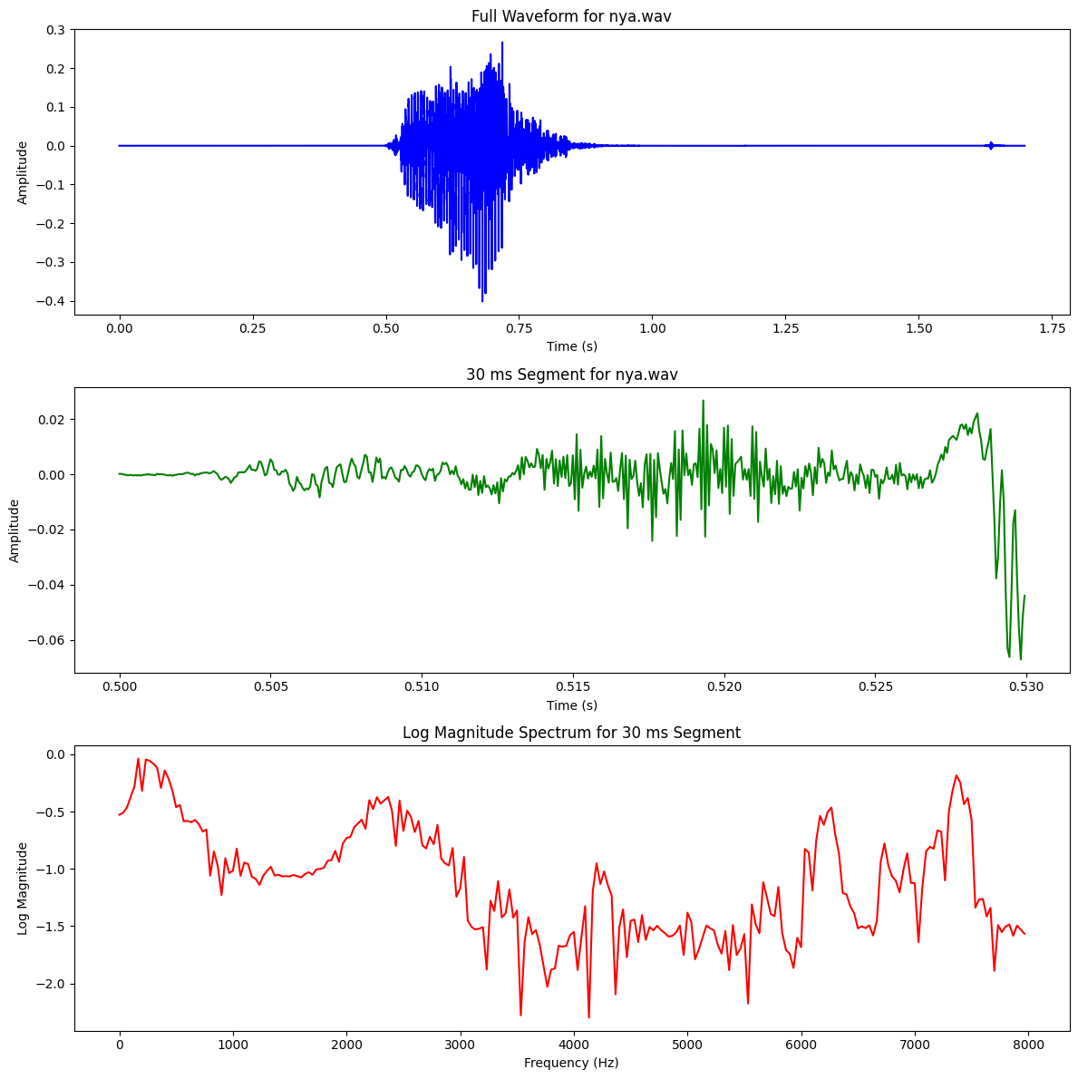

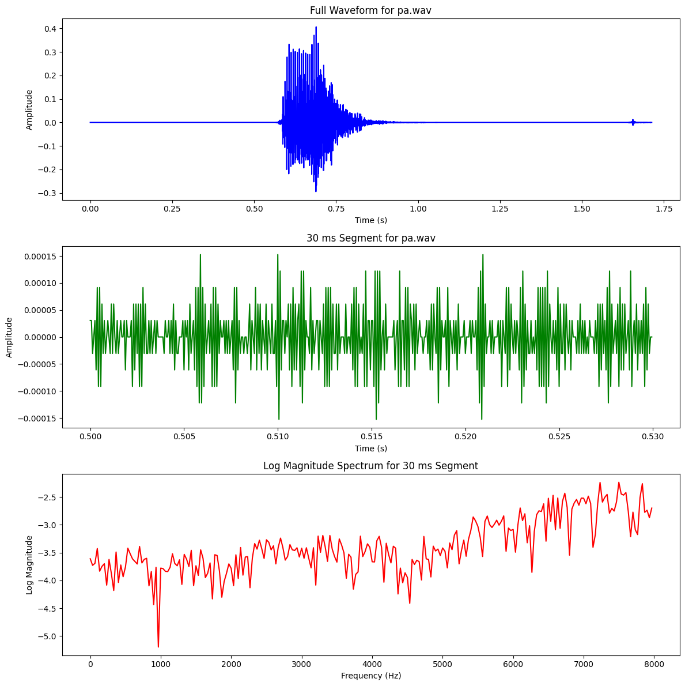 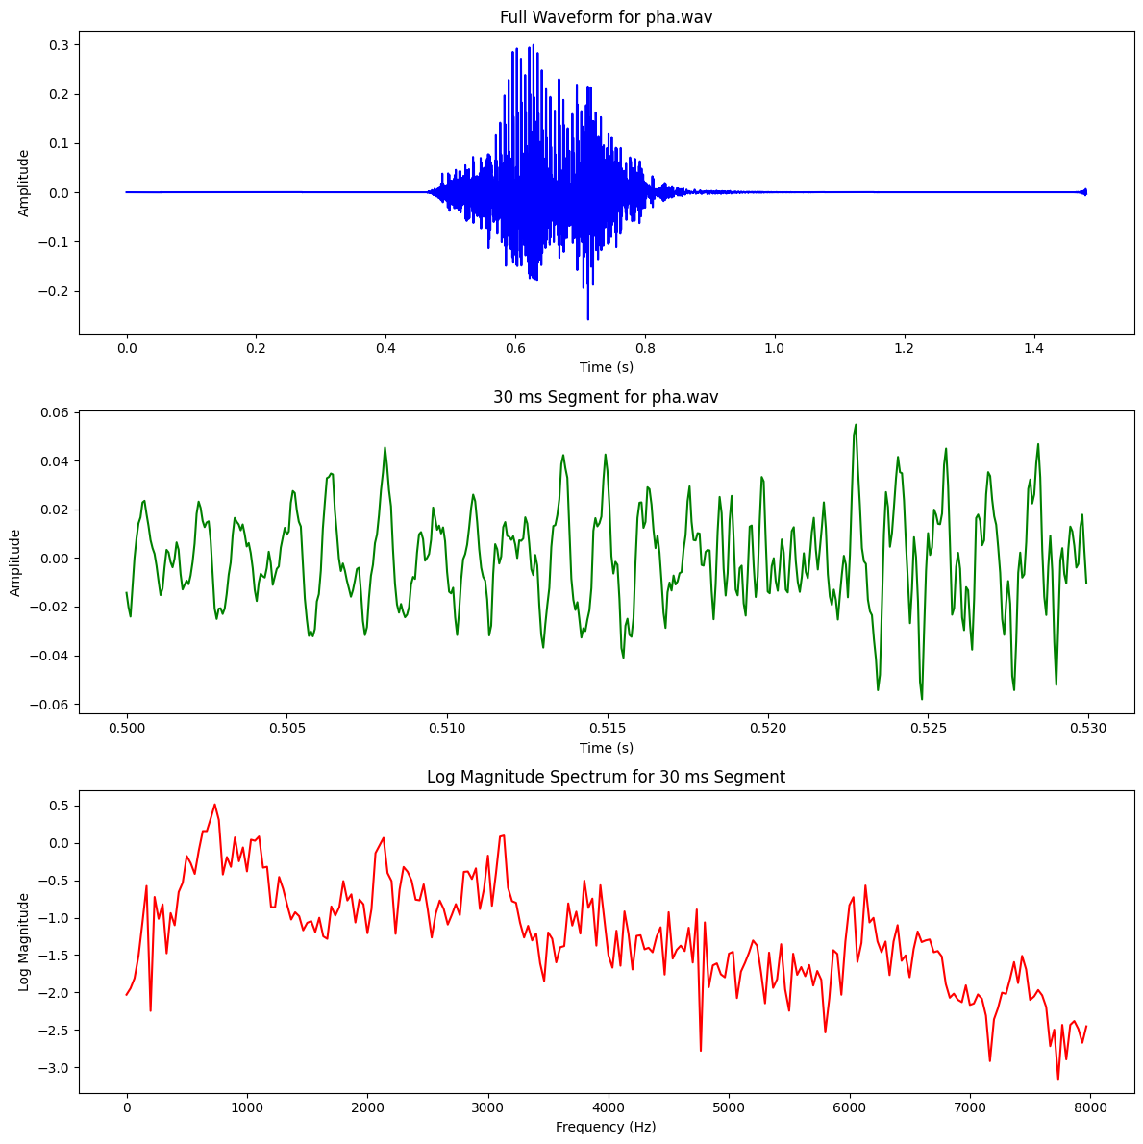

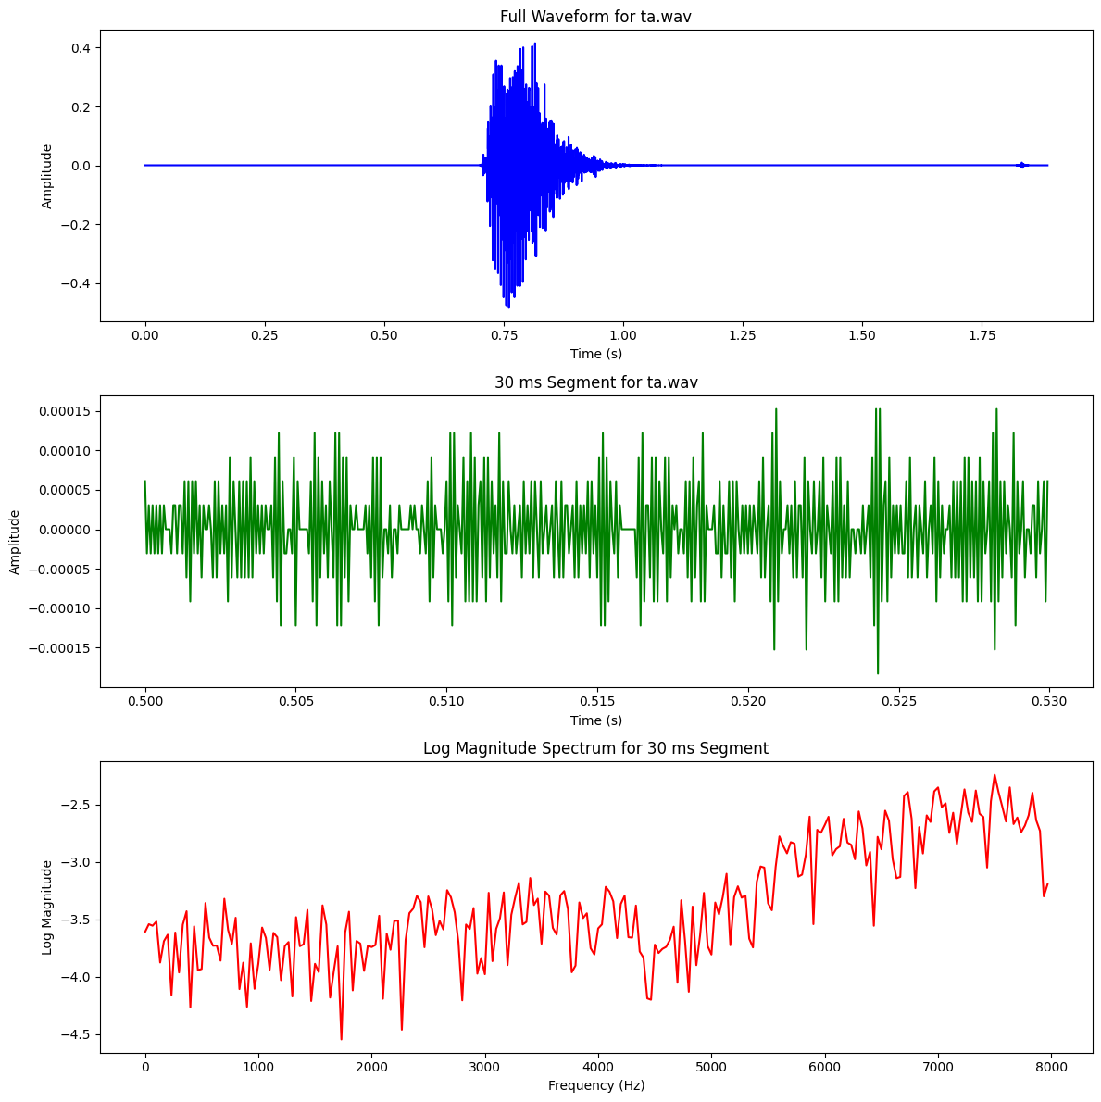 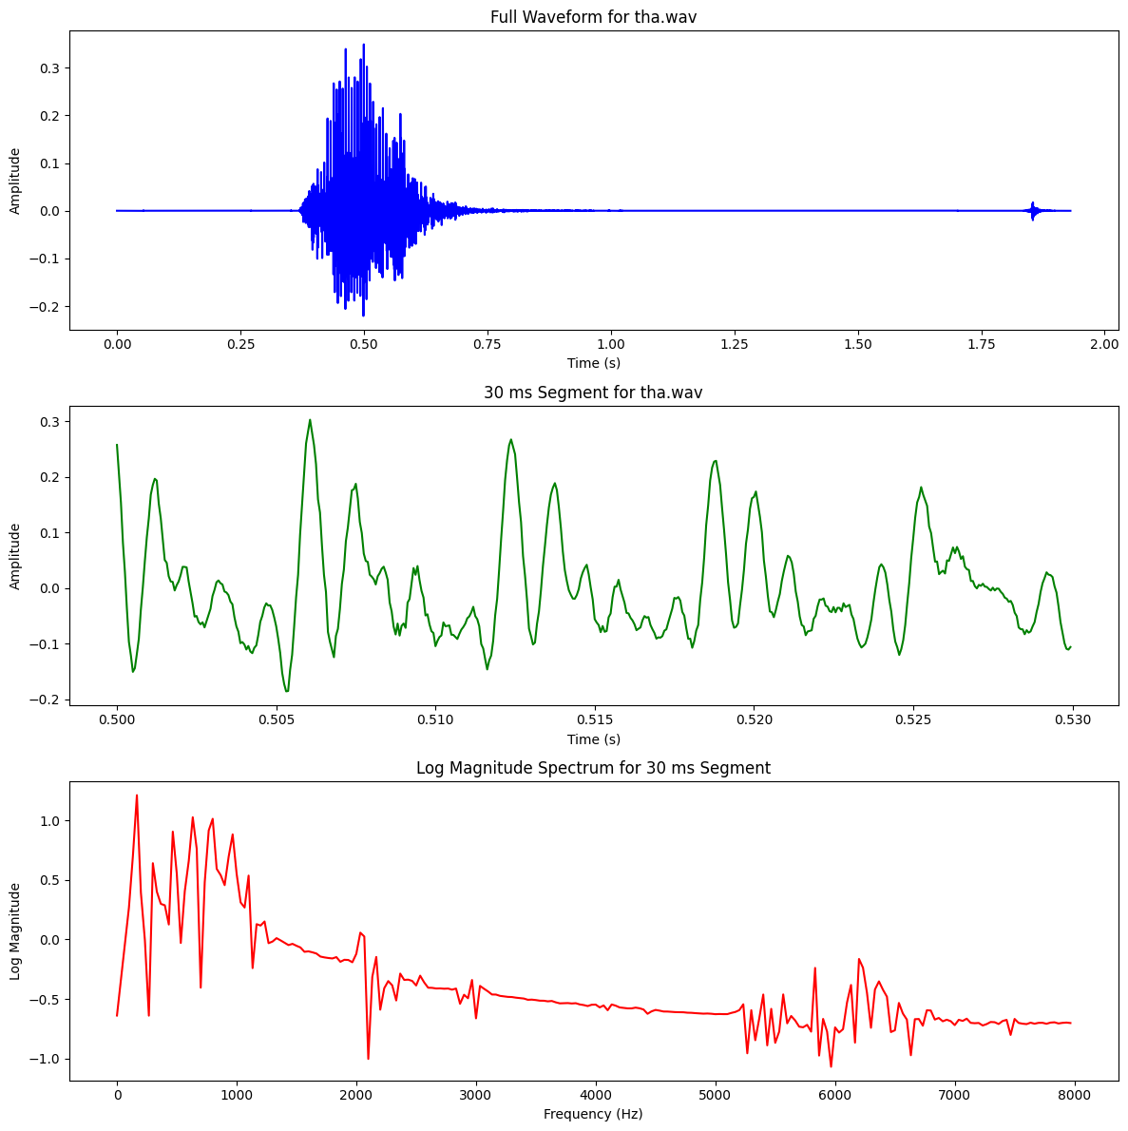

# Consonant -Nasal

| **Type** | **Phoneme (IPA)** | **Place of Articulation** | **Manner of Articulation** |
| --- | --- | --- | --- |
| **Affricates** | চ , ছ | Palatal | Stop + Friction (Affricate) |
| **Fricatives** | শ , ষ, স | Alveopalatal, Retroflex | Fricative |
| **Nasals** | ম , ন, ঙ, ণ | Bilabial, Alveolar, Velar, Retroflex | Nasal |
| **Semivowels** | য , র, ল | Palatal, Retroflex, Alveolar | Approximant (Semivowel) |
| **Stops** | ক, খ, গ, ঘ,… | Velar, Palatal, etc. | Blocking Airflow |

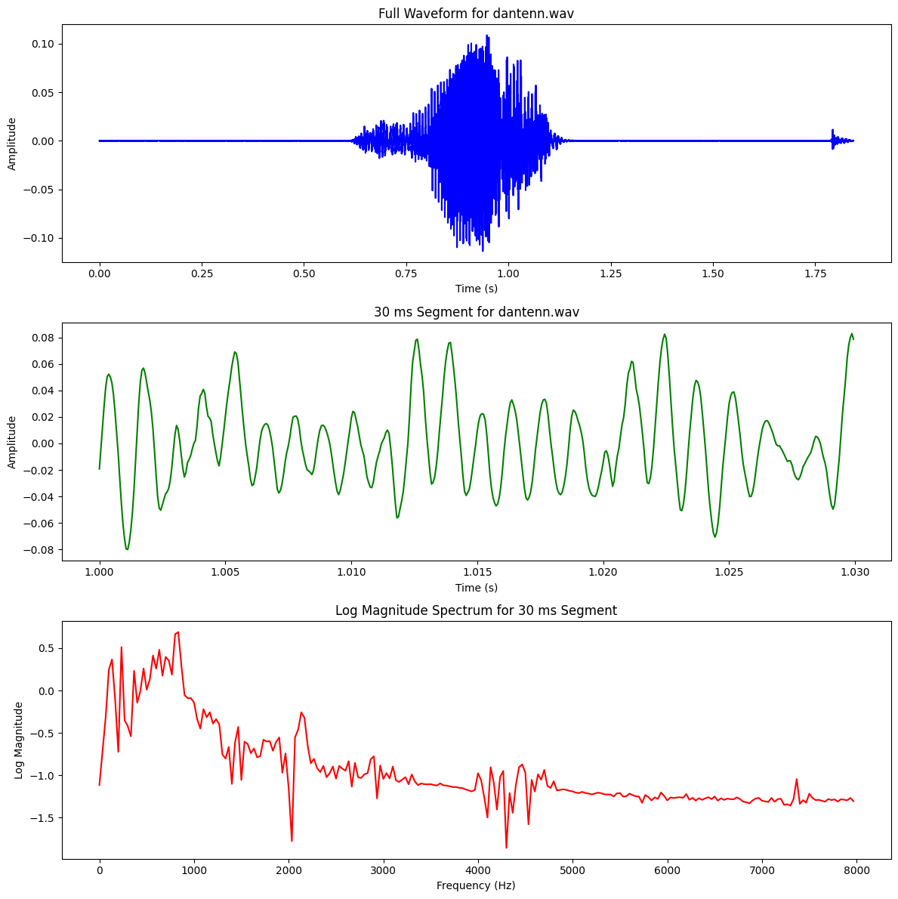 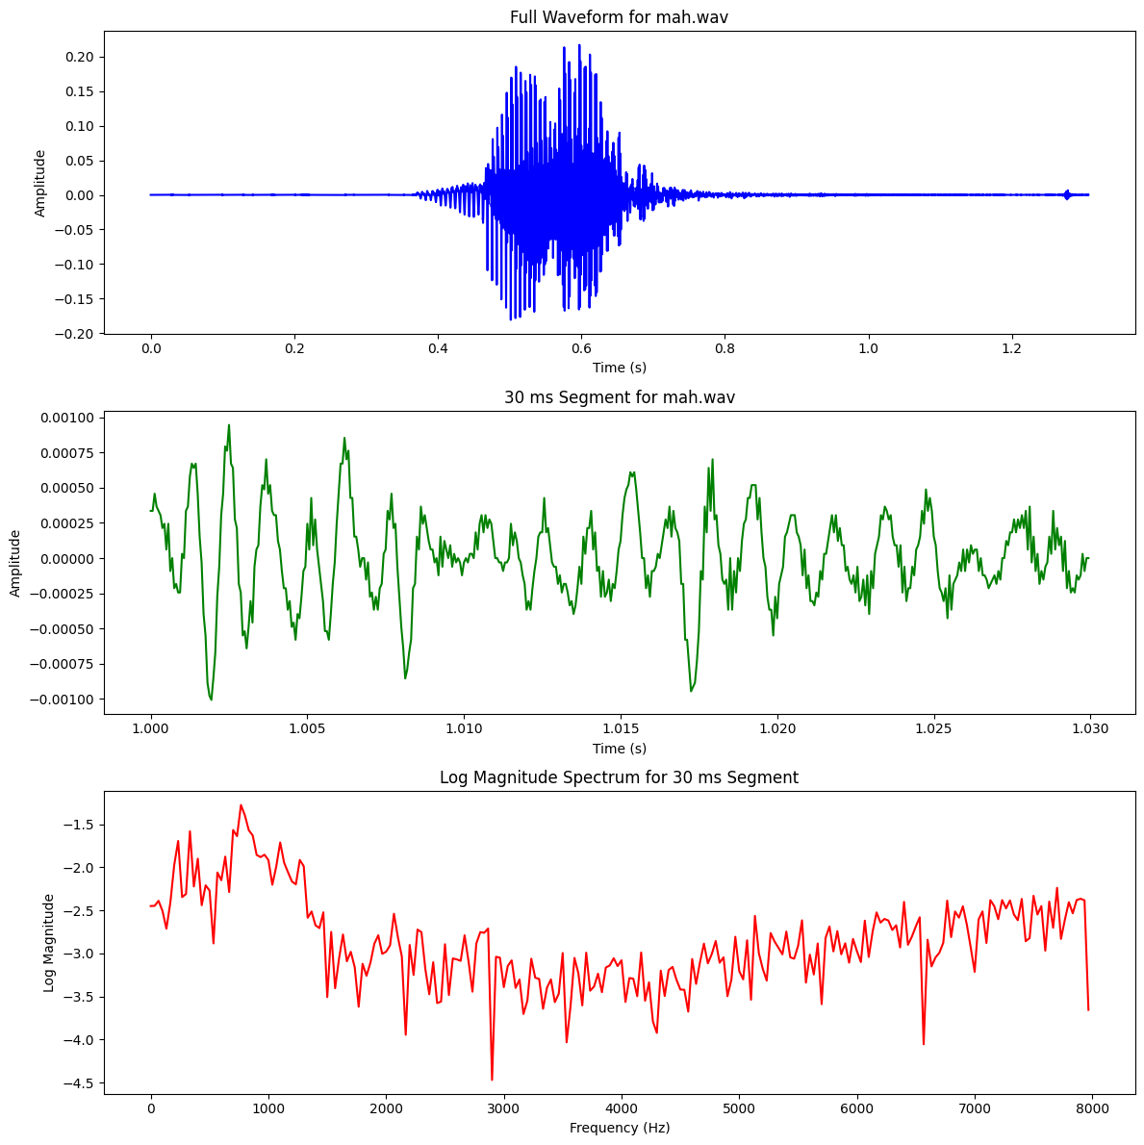

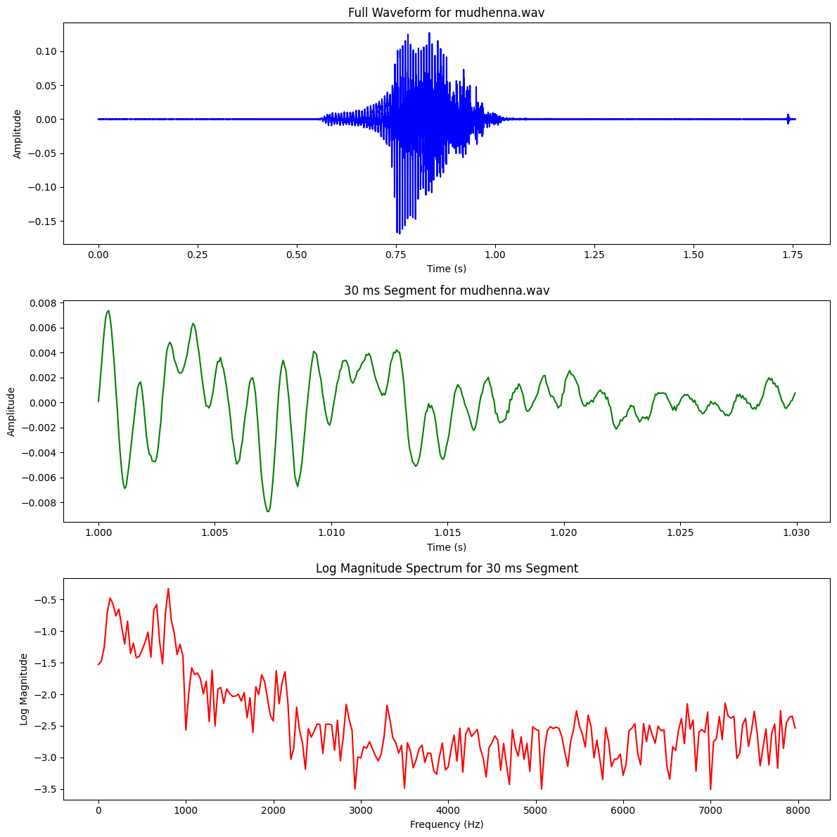 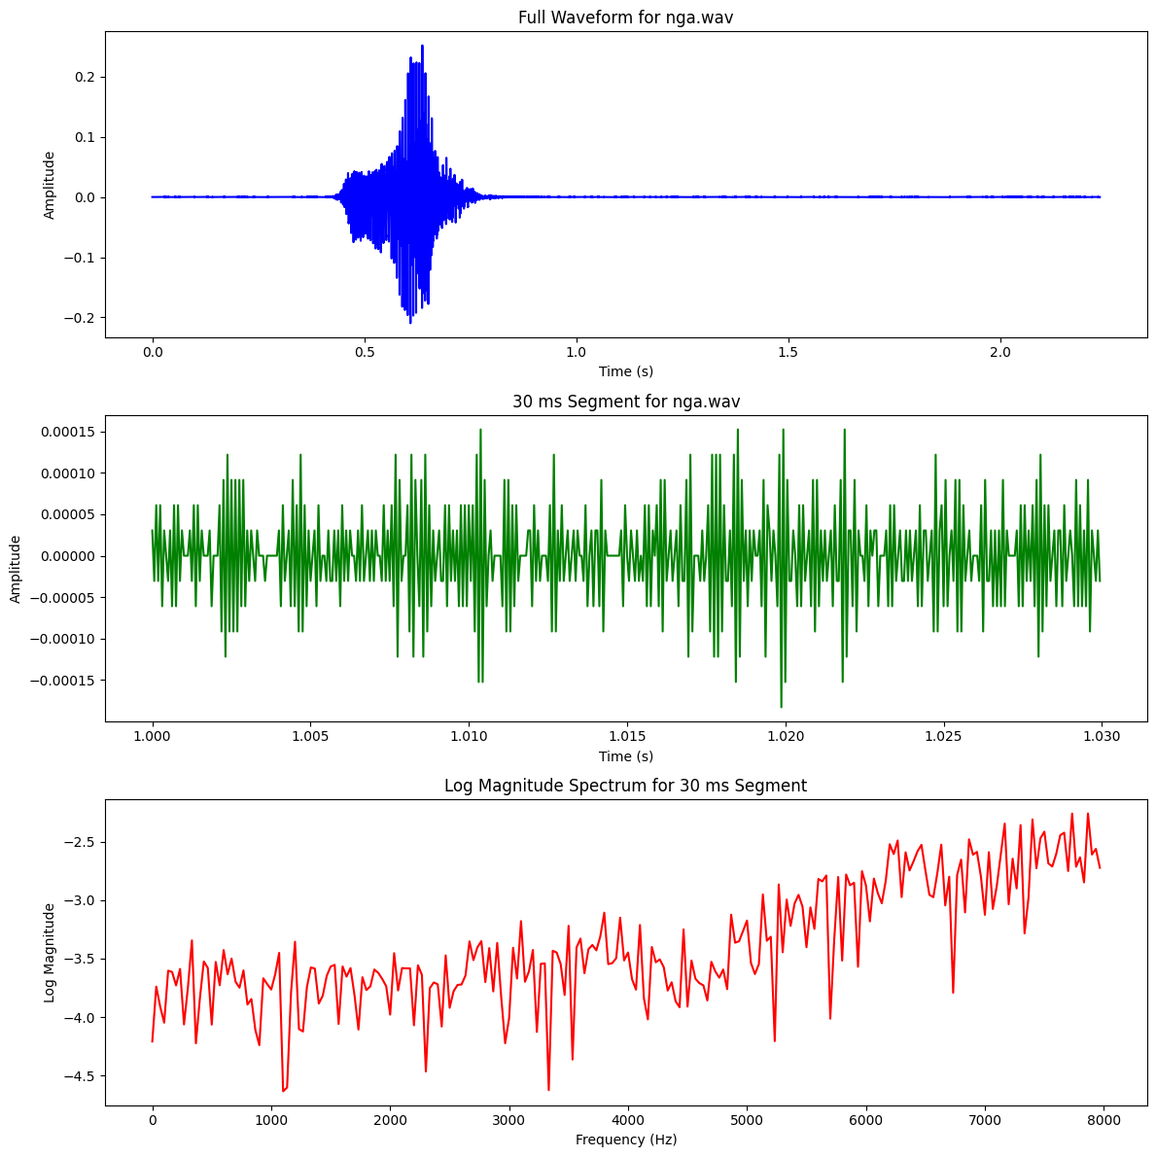

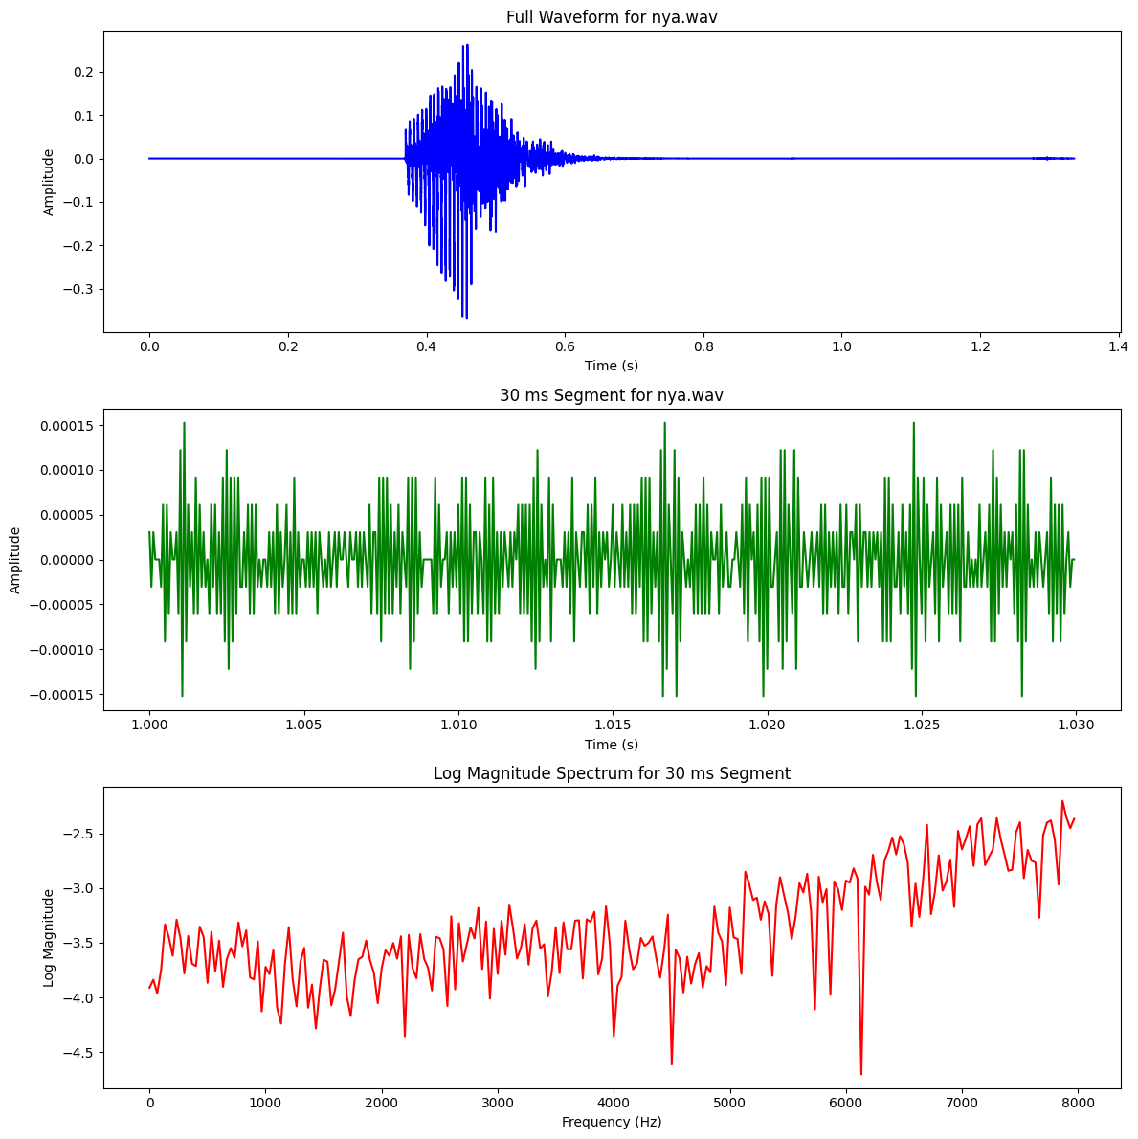

# Consonants – Fricatives

| **Type** | **Phoneme (IPA)** | **Place of Articulation** | **Manner of Articulation** |
| --- | --- | --- | --- |
| **Affricates** | চ , ছ | Palatal | Stop + Friction (Affricate) |
| **Fricatives** | শ , ষ, স | Alveopalatal, Retroflex | Fricative |
| **Nasals** | ম , ন, ঙ, ণ | Bilabial, Alveolar, Velar, Retroflex | Nasal |
| **Semivowels** | য , র, ল | Palatal, Retroflex, Alveolar | Approximant (Semivowel) |
| **Stops** | ক, খ, গ, ঘ,… | Velar, Palatal, etc. | Plosive - completely blocking the airflow in the vocal tract and then releasing it suddenly |

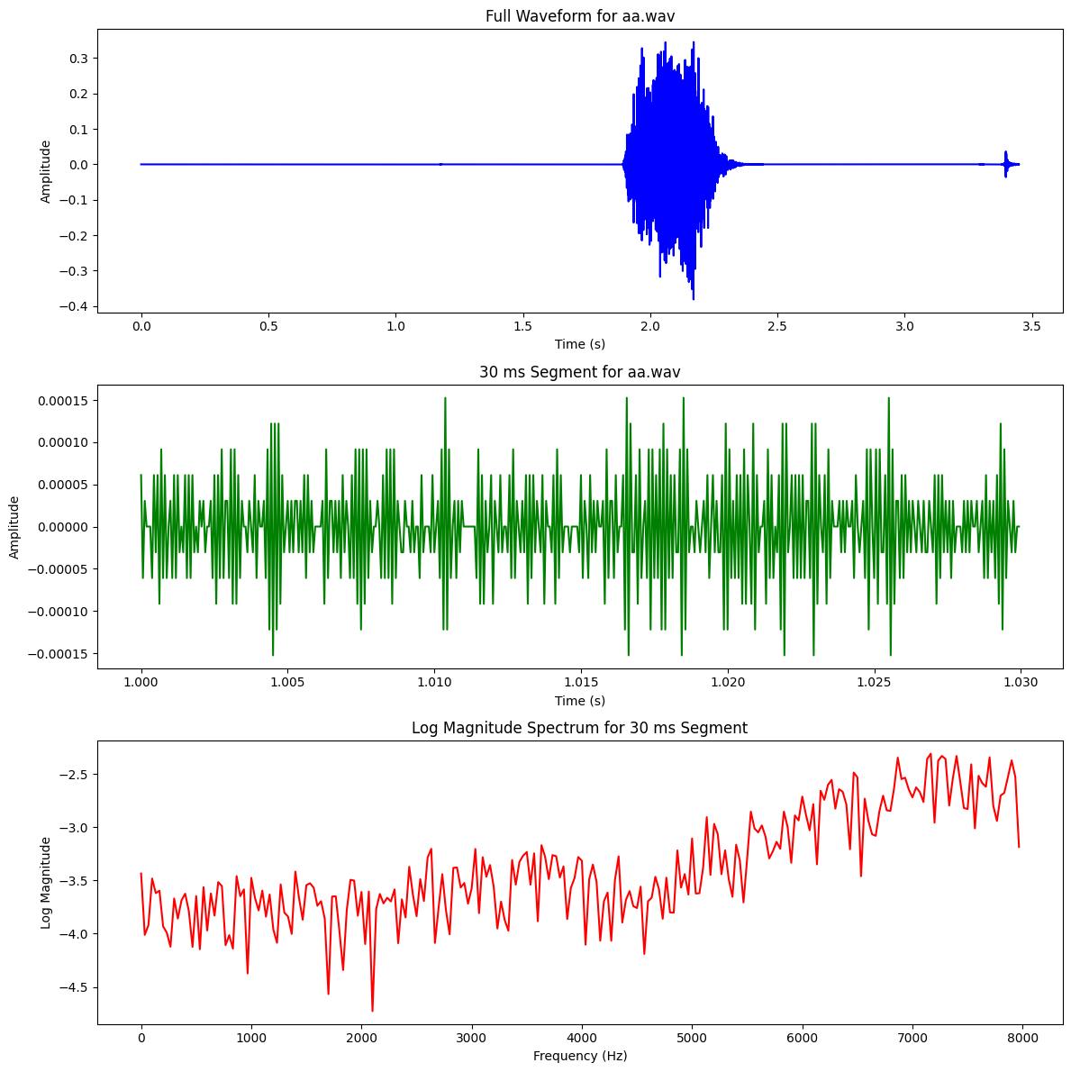 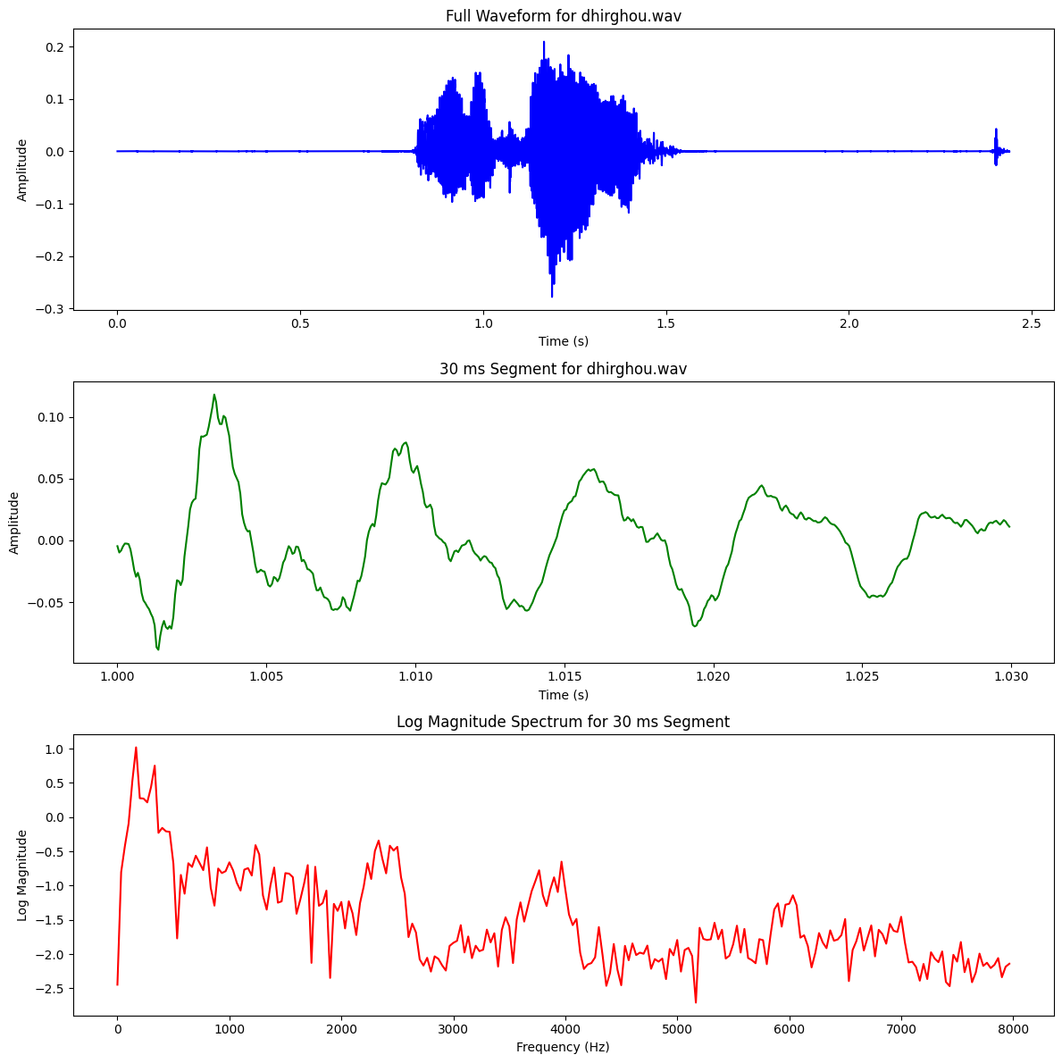

# Consonants – SemiVowel

| **Type** | **Phoneme (IPA)** | **Place of Articulation** | **Manner of Articulation** |
| --- | --- | --- | --- |
| **Affricates** | চ , ছ | Palatal | Stop + Friction (Affricate) |
| **Fricatives** | শ , ষ, স | Alveopalatal, Retroflex | Fricative |
| **Nasals** | ম , ন, ঙ, ণ | Bilabial, Alveolar, Velar, Retroflex | Nasal |
| **Semivowels** | য , র, ল | Palatal, Retroflex, Alveolar | Approximant (Semivowel) |
| **Stops** | ক, খ, গ, ঘ,… | Velar, Palatal, etc. | Plosive - completely blocking the airflow in the vocal tract and then releasing it suddenly |

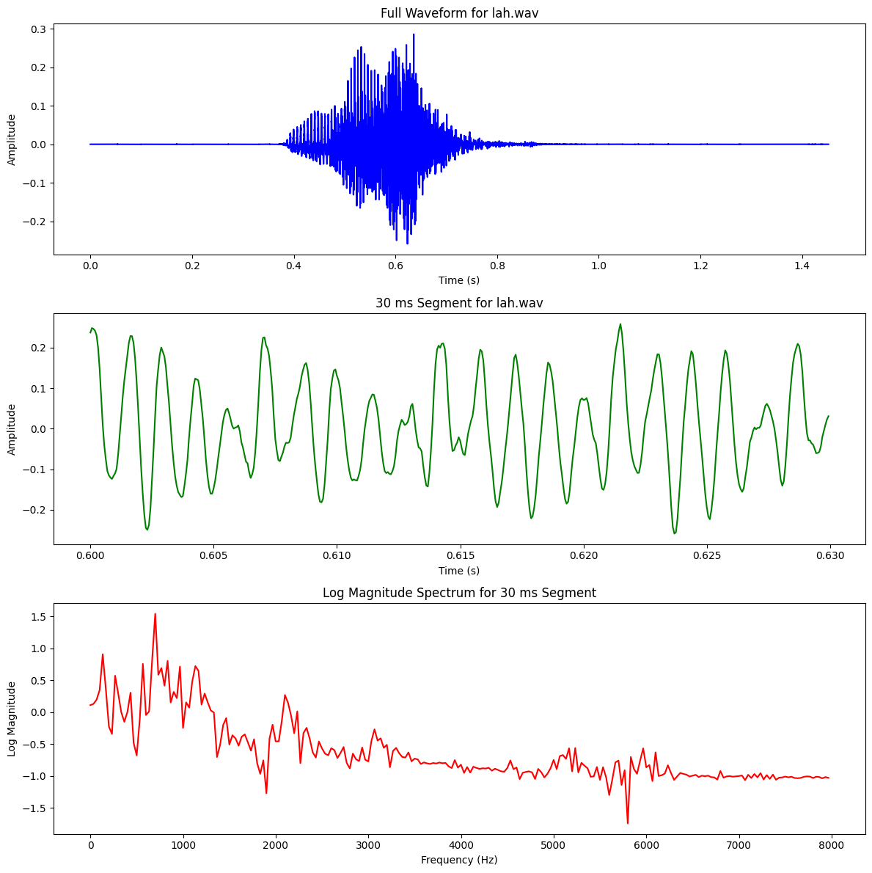 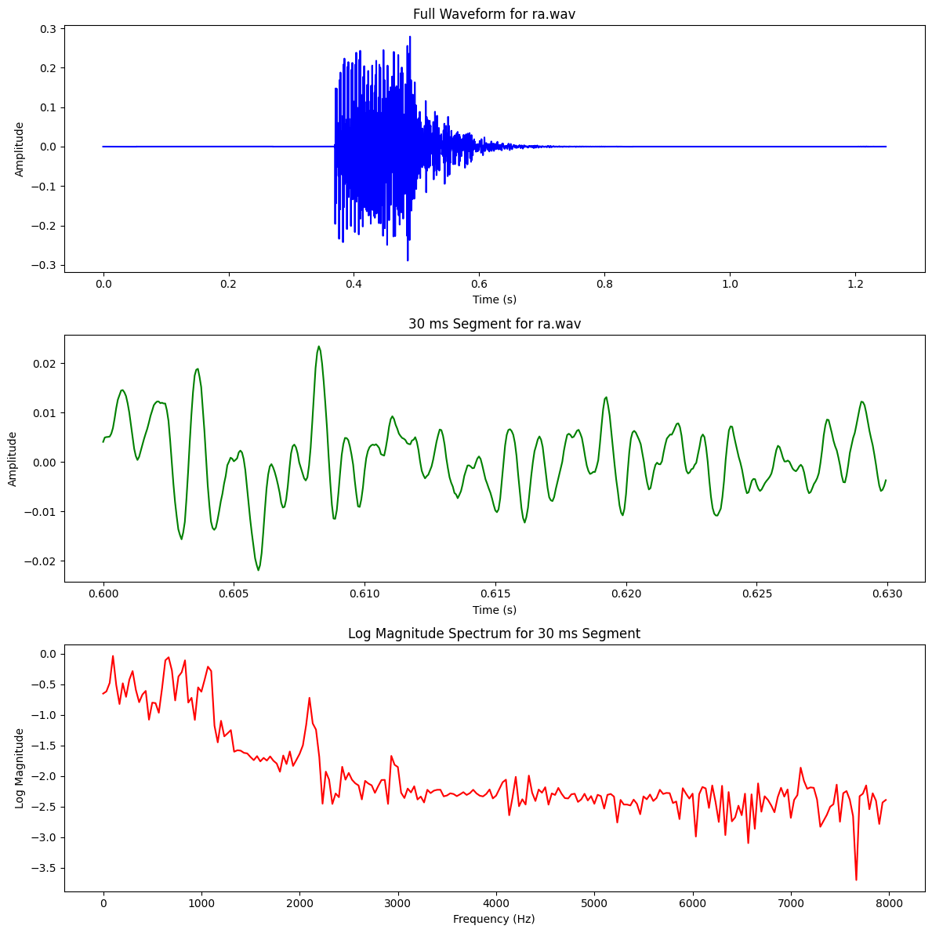

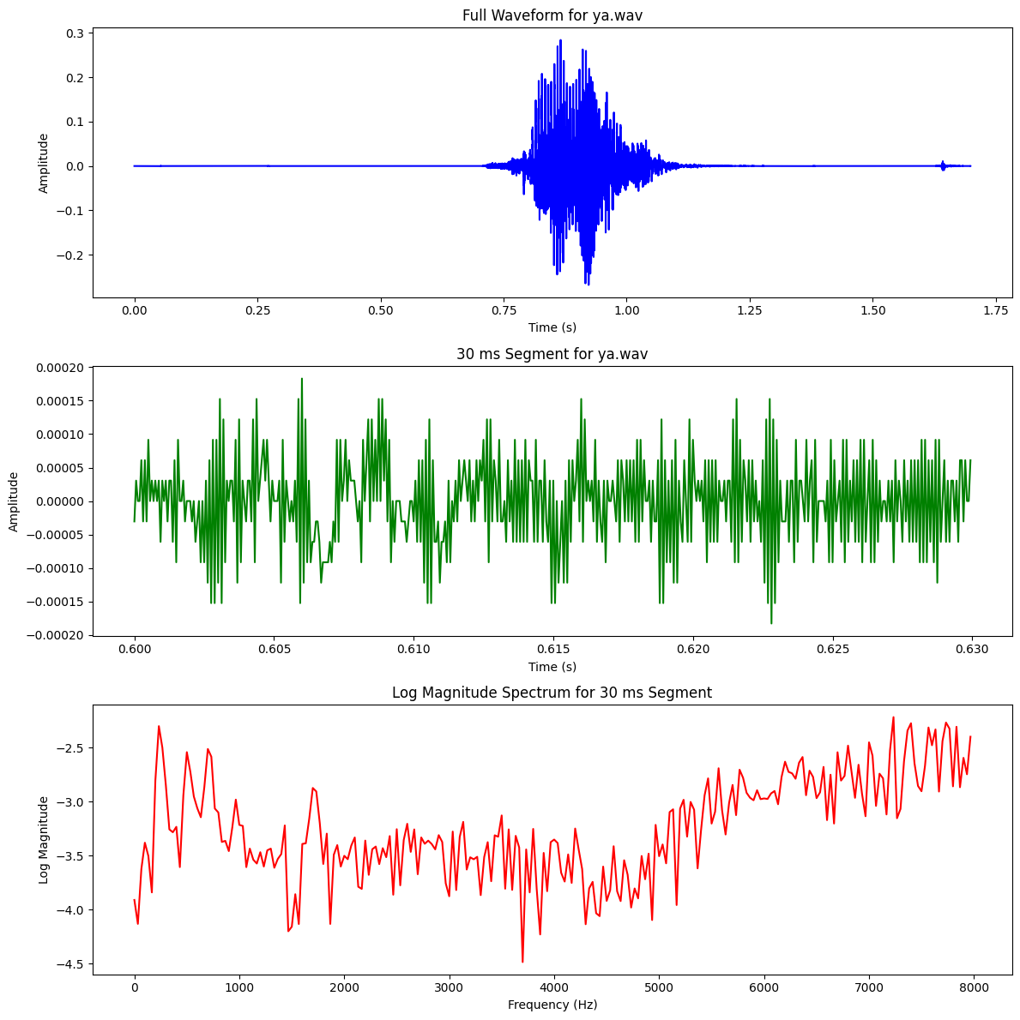 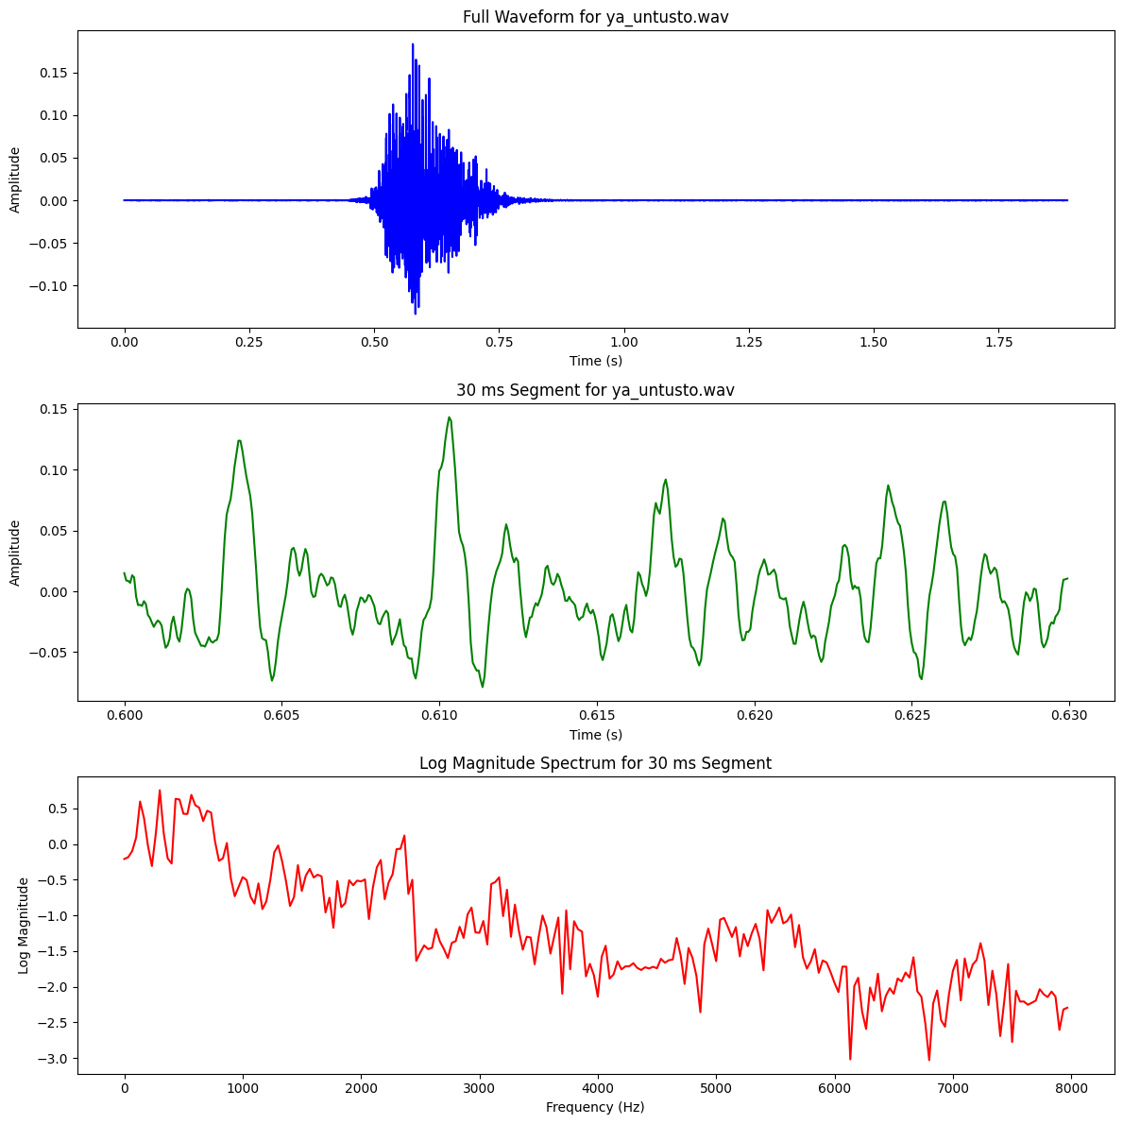

# Consonants – Affricates

| **Type** | **Phoneme (IPA)** | **Place of Articulation** | **Manner of Articulation** |
| --- | --- | --- | --- |
| **Affricates** | চ , ছ | Palatal | Stop + Friction (Affricate) |
| **Fricatives** | শ , ষ, স | Alveopalatal, Retroflex | Fricative |
| **Nasals** | ম , ন, ঙ, ণ | Bilabial, Alveolar, Velar, Retroflex | Nasal |
| **Semivowels** | য , র, ল | Palatal, Retroflex, Alveolar | Approximant (Semivowel) |
| **Stops** | ক, খ, গ, ঘ,… | Velar, Palatal, etc. | Plosive - completely blocking the airflow in the vocal tract and then releasing it suddenly |

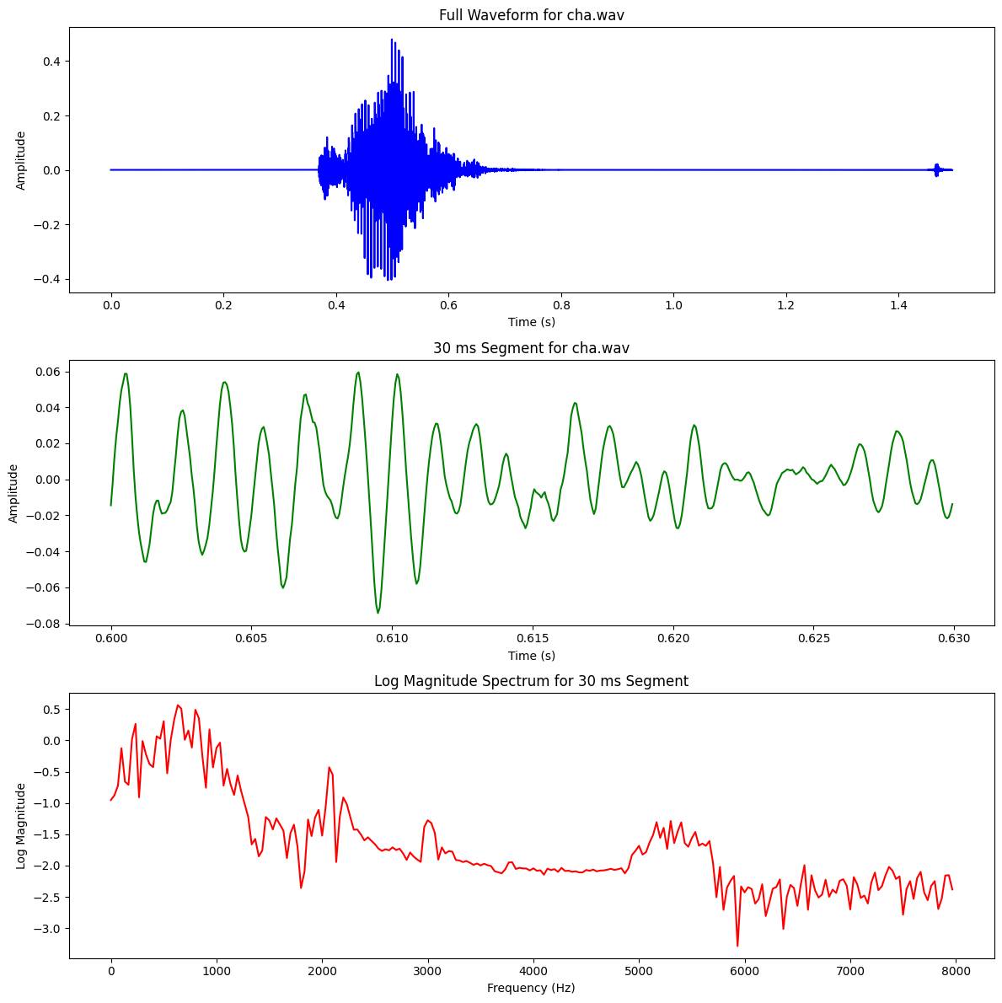 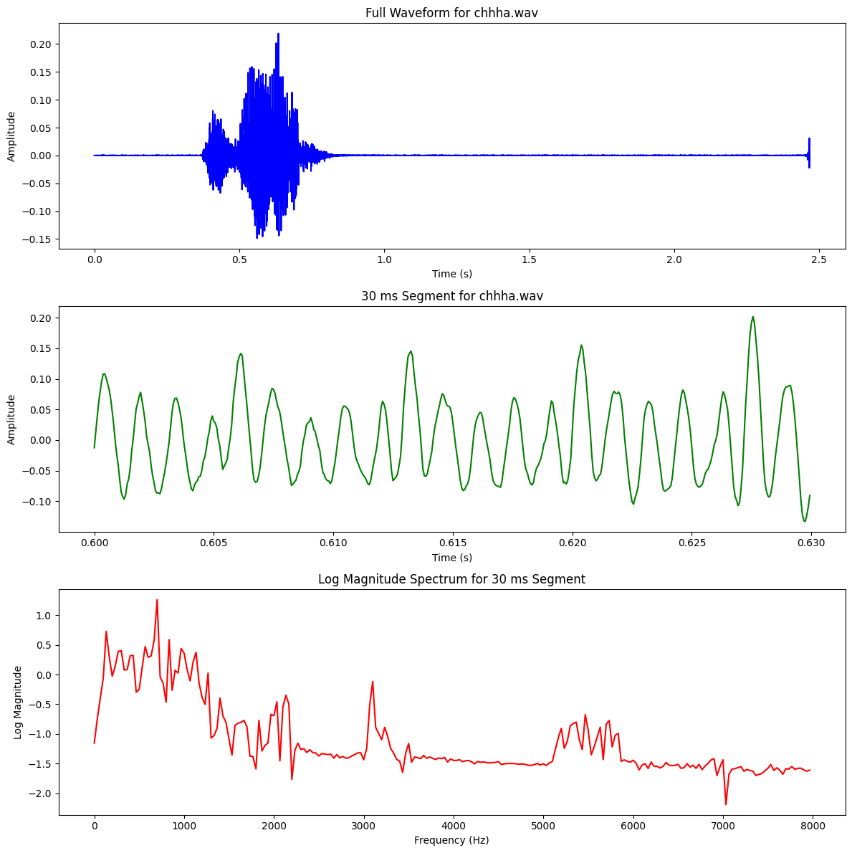

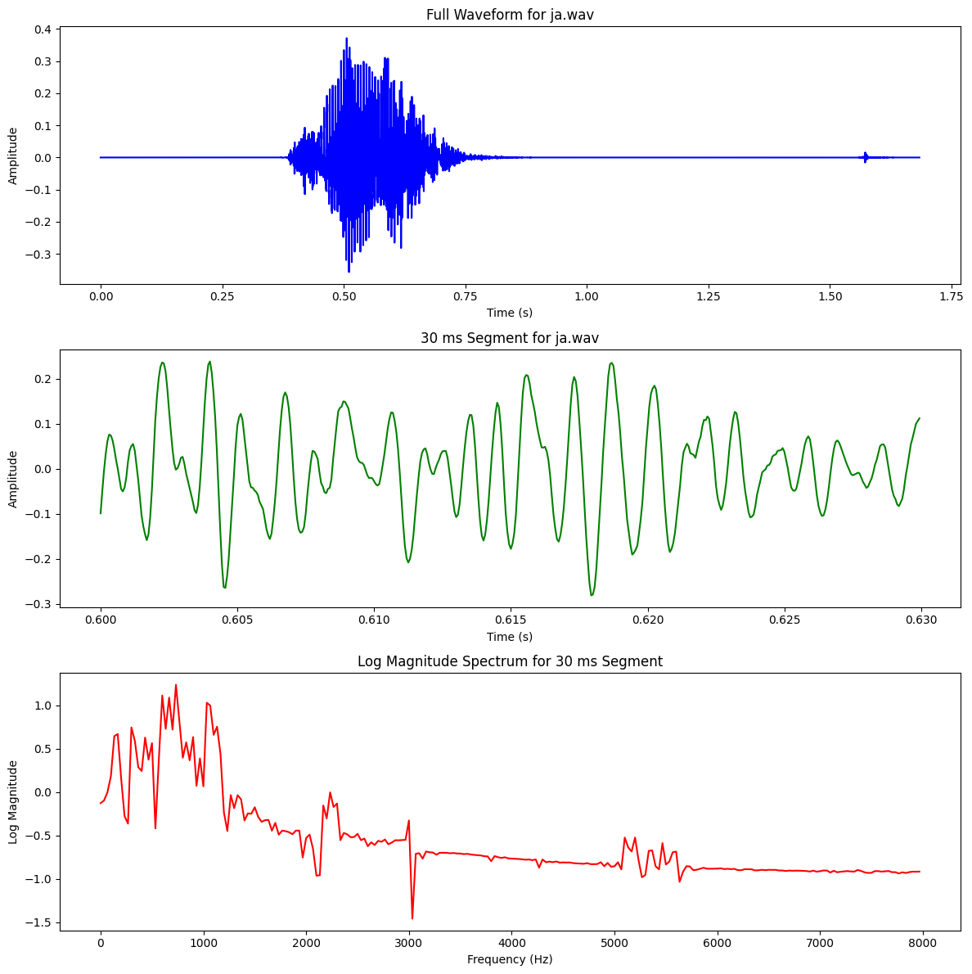 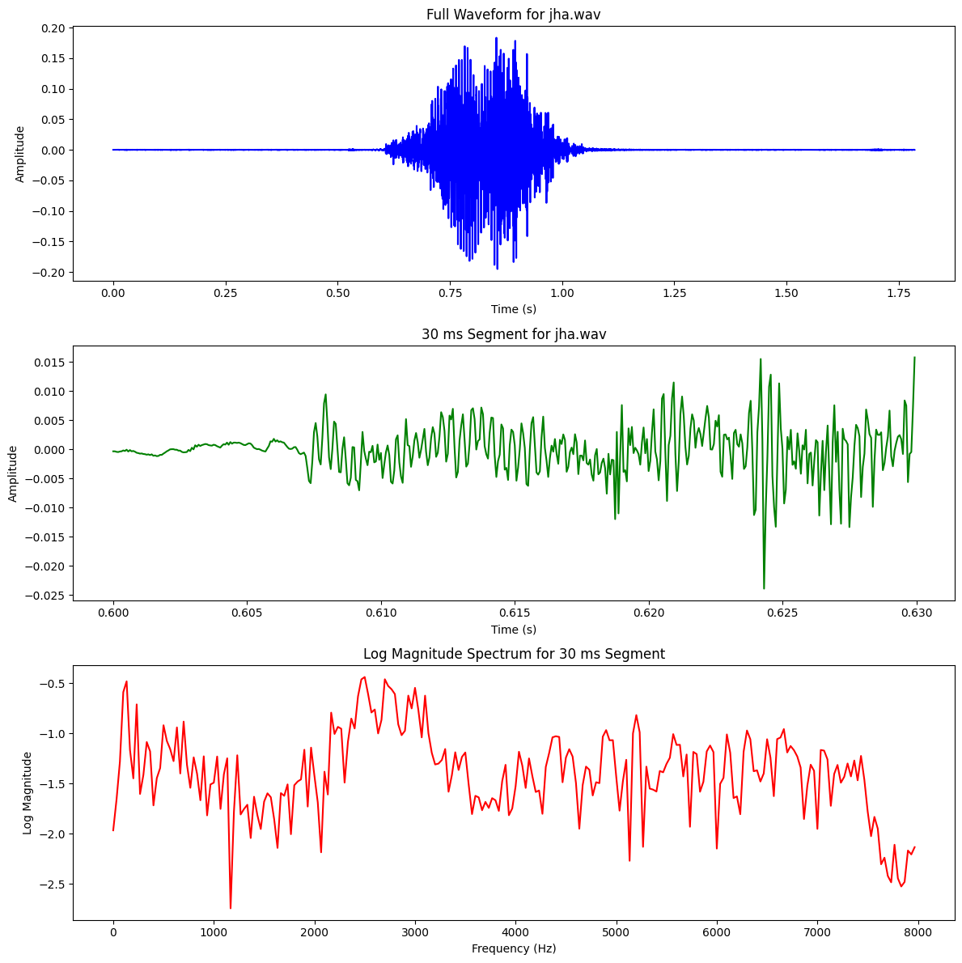

# Stop with Vowels

Plosive - completely blocking the airflow in the vocal tract and then releasing it suddenly

| **Stop Consonant** | **Example Word** | **Vowel Context** | **Place of Articulation** | **Manner of Articulation** |
| --- | --- | --- | --- | --- |
| ক (k) | "অকা" (a+ka) | Short Vowel (অ) | Velar | Plosive |
| প (p) | "অপা" (a+pa) | Short Vowel (অ) | Bilabial | Plosive |
| ট (ṭ) | "অটা" (a+ṭa) | Short Vowel (অ) | Retroflex | Plosive |
| গ (g) | "অগা" (a+ga) | Short Vowel (অ) | Velar | Plosive |
| দ (d) | "অদা" (a+da) | Short Vowel (অ) | Alveolar | Plosive |

